**APMC WEBSITE**

**BCA SEM 6 YEAR – 2023/2024**

**Develop By**

GARANIYA HARDIK B.

(003203213982)

GARANIYA KAPIL V.

(003203213983)

GARANIYA CHINTAN A.

(003203213981)

**Guide By**

Prof. J. M. Ardeshna

Prof. V. M. Isotiya

**College**

M. B. Arts & Commerce College - Gondal

**Submitted To**

Saurashtra University-Rajkot

**Acknowledgement**

The feeling of greatfulness to any one’s help directly arises from the bottom of heart. A small but an important and timely help can prove to be a milestone in one’s life.

Even human being has such kind of experience. Being human being, we also have, the same feeling of greatfulness of today we have achieved an important milestone in my life.

This project is dedicated to all the people, whom we met, took guidance, talked, interviewed and learned something from them. At this occasion we sincerely thank all of them while submitting this project report.

We would like to heartily thank Mr. J. M. Ardeshna & Mr. V. M. Isotiya who has provided us necessary information and guidance for the success of this project.

Last, we would like to extend thanks to all our classmates also. On this occasion we would like to thank Mr. V. M. Isotiya (HOD, Computer Department) without whom this would have not been possible. We are thankful to him for giving time-to-time and valuable guidance during the project period and giving us guidance in taking our curriculum decision and choosing, initiating and getting on with the project.

We always have felt the invisible help from the almighty, without the blessing almighty, we could not have succeeded.

**Index Content**

|  |  |  |
| --- | --- | --- |
| **Chapter No** | **Content** | |
| 1 | Project Profile | |
| 2 | System Analysis | |
|  | 2.1 | The Existing system |
|  | 2.2 | Problem Definition |
| 3 | Hardware & Software Specifications | |
| 4 | System Design | |
|  | 4.1 | Context Diagram |
|  | 4.2 | Data Flow Diagram |
|  | 4.3 | Entity Relationship Diagram |
|  | 4.4 | Data Dictionary |
| 5 | Input and Output Design | |
|  | 5.1 | Screen Shots |
| 6 | Testing | |
| 7 | Future scope and limitations | |
| 8 | Bibliography | |
| 9 | Special Thanks | |

**Project Profile**

|  |  |
| --- | --- |
| **Project Title** | APMC Market Yard Website |
| **Developer for** | APMC GONDAL |
| **Internal project guide** | Mr. Vinod M. Isotiya  Mr. Jaimin S. Ardeshna |
| **Team Size** | 3 |
| **Team Member** | Garaniya Hardik B.  Garaniya Kapil V.  Garaniya Chintan A. |
| **Hardware configuration** | Processor : Intel I3  Ram :-4 Gb  Hard disk : - 500 Gb |
| **Front end** | Microsoft ASP.Net 2008 with C# |
| **Back end** | SQL Server 2005 |
| **Operating system** | Microsoft 7 |

**Hardware and Software**

Hardware :-( Recommended)

Processor : Intel I3

Random Access Memory : 4 Gb

Hard Disk : 500 Gb

Software :-( Recommended)

Front-End : Visual Studio 2008

Web Server : IIS 5.1

Back End : SQL server 2005

Support : Framework 2.0

Operating System : Windows XP (service pack 2)

Supporting tools : Microsoft Word for document

**System Design**

APMC

**User Side Diagram**

Progress

Home

Sign up

Announcement

Commission

Agent

Login

Feedback

About us

**C.A. Side Diagram**

PROGRESS

HOME

LOGOUT

ANNOUNCEMENT

ABOUT US

FEEDBACK

**Admin Side Diagram**

Progress

Home

Crop

Logout

Admin

Feedback

Commission

Agent

Announcement

**ER Diagram**

|  |
| --- |
| User id |
| Progress id |
| Crop name |
| Low price |
| High price |
| Income |
| Outgoing |
| Date |

|  |
| --- |
| User Id |
| Firm name |
| Password |
| Shop number |
| Mobile number |
| Is Approved |
| Email |
| User Type |

|  |
| --- |
| Feedback_id |
| Name |
| Email |
| Message |

|  |
| --- |
| Crop_id |
| Croname |

|  |
| --- |
| Announcement_id |
| Date |
| Notice |

**Data Dictionary**

|  |  |
| --- | --- |
| **Table Known** | **Table Name** |
| User | login and sign up |
| Crop | Crop |
| Progress | Progress |
| Announcement | Announcement |
| Feedback | Feedback |

**Data Dictionary**

* **Table Name:- User**

**Purpose:- Admin Login Commission Agent Login**

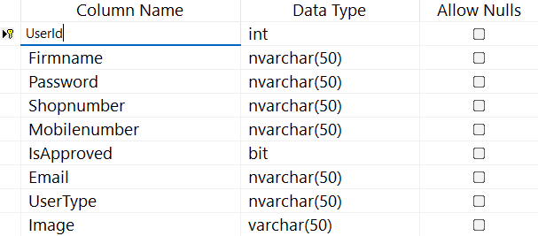

* **Table Name:- Crop Table**

**Purpose: - Add Crop**

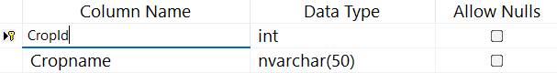

* **Table Name:- Announcement**

**Purpose:- Add and View Announcement**

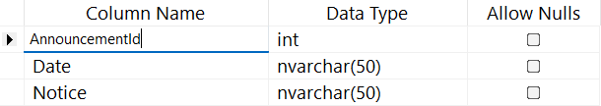

* **Table Name:- Progress**

**Purpose: - Market Daily Progress**

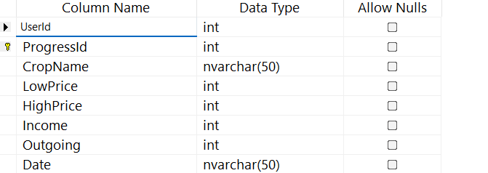

* **Table Name:- Feedback**

**Purpose:- Add and View Feddback**

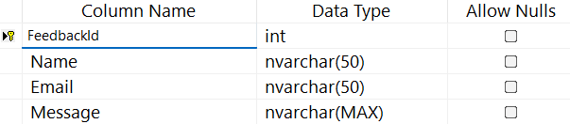

**-: Input & Output Design :-**

**Screen Layout**

* **C.A. SIDE**

**Home.aspx**



**Coding :-**

**:=>Home.aspx**

<%@ Page Language="C#" MasterPageFile="~/C.A/MasterPage.master" AutoEventWireup="true" CodeFile="Home.aspx.cs" Inherits="_Default" Title="Untitled Page" %>

<asp:Content ID="Content1" ContentPlaceHolderID="head" Runat="Server">

</asp:Content>

<asp:Content ID="Content2" ContentPlaceHolderID="ContentPlaceHolder1" Runat="Server">

<img src="../img/apmclogo.jpeg.jpeg" width="1535px" height="640px"/>

</asp:Content>

**:=>**[**Home.aspx.cs**](http://Home.aspx.cs)

using System;

using System.Collections;

using System.Configuration;

using System.Data;

using System.Linq;

using System.Web;

using System.Web.Security;

using System.Web.UI;

using System.Web.UI.HtmlControls;

using System.Web.UI.WebControls;

using System.Web.UI.WebControls.WebParts;

using System.Xml.Linq;

public partial class _Default : System.Web.UI.Page

{

protected void Page_Load(object sender, EventArgs e)

{

}

}

**:=> MasterPage.master**

<%@ Master Language="C#" AutoEventWireup="true" CodeFile="MasterPage.master.cs" Inherits="MasterPage" %>

<!DOCTYPE html PUBLIC "-//W3C//DTD XHTML 1.0 Transitional//EN" "http://www.w3.org/TR/xhtml1/DTD/xhtml1-transitional.dtd">

<html xmlns="http://www.w3.org/1999/xhtml">

<head runat="server">

<title>Untitled Page</title>

<asp:ContentPlaceHolder id="head" runat="server">

</asp:ContentPlaceHolder>

<style>

body{

margin: 0px;

padding:0px;

background-color: Silver;

}

.welcome {

font-size: 25px;

color: white;

margin-top: 10px;

font-weight: bold;

}

nav{

background-color:darkBlue;

display: flex;

justify-content: space-around;

align-items: center;

padding: 15px 30px;

}

nav h2{

color: white;

}

nav ul{

display: flex;

justify-content: center;

align-items: center;

}

nav ul li{

list-style: none;

padding: 4px 20px;

justify-content: space-around;

}

nav ul li a{

color: white;

font-size: 18px;

text-decoration: none;

}

</style>

</head>

<body>

<form id="form1" runat="server" enableviewstate="True">

<div class="hardik">

<div class="header">

<nav>

<div class="user-welcome">

<asp:Label ID="lblWelcome" runat="server" CssClass="welcome"></asp:Label>

</div>

<ul>

<li><a href="Home.aspx">HOME</a> </li>

<li><a href="Progress.aspx">PROGRESS</a> </li>

<li><a href="Annaucement.aspx">ANNAUNCEMENT</a> </li>

<li><a href="Feedback.aspx">FEEDBACK</a> </li>

<li><a href="AboutUs.aspx">ABOUT US</a> </li>

<li><a href="Logout.aspx">LOGOUT</a> </li>

</ul>

</nav>

</div>

<div class="content">

<asp:ContentPlaceHolder id="ContentPlaceHolder1" runat="server">

</asp:ContentPlaceHolder>

</div>

<div class="footer">

</div>

</div>

</form>

</body>

</html>

**:=> MasterPage.master.cs**

using System;

using System.Collections;

using System.Configuration;

using System.Data;

using System.Linq;

using System.Web;

using System.Web.Security;

using System.Web.UI;

using System.Web.UI.WebControls;

using System.Web.UI.WebControls.WebParts;

using System.Web.UI.HtmlControls;

using System.Xml.Linq;

public partial class MasterPage : System.Web.UI.MasterPage

{

protected void Page_Load(object sender, EventArgs e)

{

if (Session["UserId"] != null && Session["Firmname"] != null)

{

int userId = Convert.ToInt32(Session["UserId"]);

string userName = Session["Firmname"] != null ? Session["Firmname"].ToString() : string.Empty;

lblWelcome.Text = "Welcome, " + userName;

}

else

{

Response.Redirect("Home.aspx");

}

}

}

**Progress.aspx**

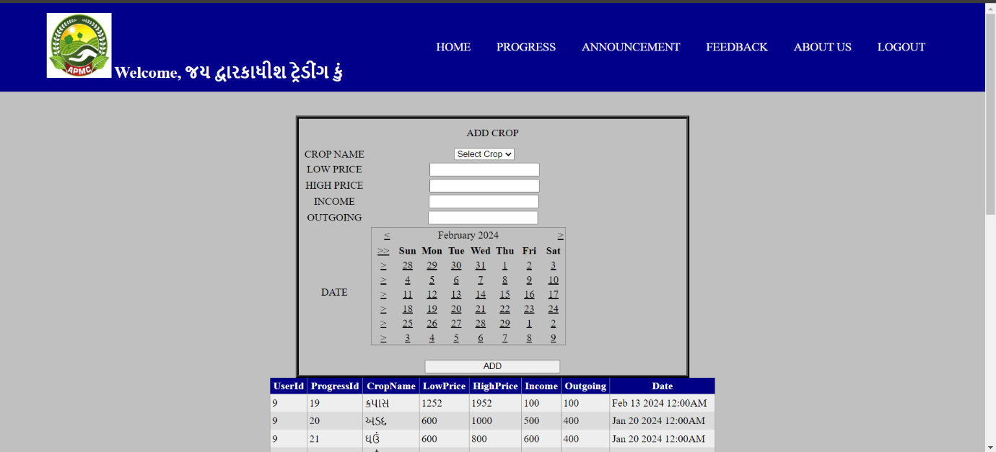

**Coding :-**

**:=>Progress.aspx**

<%@ Page Language="C#" MasterPageFile="~/C.A/MasterPage.master" AutoEventWireup="true" CodeFile="Progress.aspx.cs" Inherits="_Default" Title="Untitled Page" %>

<asp:Content ID="Content1" ContentPlaceHolderID="head" Runat="Server">

<style type="text/css">

.style1

{

width: 40%;

text-align:center;

border:5px black ridge;

margin:auto;

}

.style2

{ height: 39px;

}

.style3

{

width: 1249px;

}

.style4

{

height: 8px;

}

.style5

{

width: 1249px;

height: 29px;

}

.style6

{

height: 29px;

width: 170px;

}

.style7

{

width: 170px;

}

</style>

</asp:Content>

<asp:Content ID="Content2" ContentPlaceHolderID="ContentPlaceHolder1" Runat="Server">

<br />

<br />

<table class="style1">

<tr>

<td class="style2" colspan="2">

ADD CROP</td>

</tr>

<tr>

<td class="style7">

CROP NAME</td>

<td class="style3">

<asp:DropDownList ID="CropDropDownList" runat="server" AppendDataBoundItems="True"

DataTextField="CropName" DataValueField="CropName">

<asp:ListItem Text="Select Crop" Value="" />

</asp:DropDownList>

&nbsp;&nbsp;&nbsp;

<asp:RequiredFieldValidator ID="RequiredFieldValidator7" runat="server"

ControlToValidate="CropDropDownList" ErrorMessage="Please select crop"></asp:RequiredFieldValidator>

</td>

</tr>

<tr>

<td class="style7">

LOW PRICE</td>

<td class="style3">

&nbsp;

<asp:TextBox ID="LpriceTextBox" runat="server" MaxLength="5"></asp:TextBox>

<asp:RequiredFieldValidator ID="RequiredFieldValidator3" runat="server"

ControlToValidate="LpriceTextBox" ErrorMessage="Please enter low price"></asp:RequiredFieldValidator>

</td>

</tr>

<tr>

<td class="style7">

HIGH PRICE</td>

<td class="style3">

&nbsp;&nbsp;

<asp:TextBox ID="HpriceTextBox" runat="server" MaxLength="5"></asp:TextBox>

<asp:RequiredFieldValidator ID="RequiredFieldValidator4" runat="server"

ControlToValidate="HpriceTextBox" ErrorMessage="Please enter high price"></asp:RequiredFieldValidator>

</td>

</tr>

<tr>

<td class="style7">

INCOME</td>

<td class="style3">

&nbsp;<asp:TextBox ID="IncomeTextBox" runat="server" MaxLength="5"></asp:TextBox>

&nbsp;<asp:RequiredFieldValidator ID="RequiredFieldValidator5" runat="server"

ControlToValidate="IncomeTextBox" ErrorMessage="Please enter income"></asp:RequiredFieldValidator>

</td>

</tr>

<tr>

<td class="style7">

OUTGOING</td>

<td class="style3">

&nbsp;&nbsp;

<asp:TextBox ID="OutgoingTextBox" runat="server" MaxLength="5"></asp:TextBox>

&nbsp;&nbsp;

<asp:RequiredFieldValidator ID="RequiredFieldValidator6" runat="server"

ControlToValidate="OutgoingTextBox" ErrorMessage="Please enter outgoing"></asp:RequiredFieldValidator>

</td>

</tr>

<tr>

<td class="style6">

DATE</td>

<td class="style5">

<asp:Calendar ID="Calendar1" runat="server" SelectedDate="01/25/2024 17:26:12"

SelectionMode="None"></asp:Calendar> &nbsp;&nbsp;&nbsp;&nbsp;&nbsp;&nbsp;&nbsp;&nbsp;&nbsp;&nbsp;&nbsp;

</td>

</tr>

<tr>

<td class="style4" colspan="2">

<asp:Button ID="AddButton" runat="server" onclick="AddButton_Click"

Text="ADD" Width="209px" />

</td>

</tr>

</table>

<asp:GridView ID="GridView1" runat="server" BackColor="White"

BorderColor="#999999" BorderStyle="None" BorderWidth="1px" CellPadding="3"

HorizontalAlign="Center" Height="133px" Width="687px" GridLines="Vertical">

<RowStyle BackColor="#EEEEEE" ForeColor="Black" />

<FooterStyle BackColor="#CCCCCC" ForeColor="Black" />

<PagerStyle BackColor="#999999" ForeColor="Black" HorizontalAlign="Center" />

<SelectedRowStyle BackColor="#008A8C" Font-Bold="True" ForeColor="White" />

<HeaderStyle BackColor="#000084" Font-Bold="True" ForeColor="White" />

<AlternatingRowStyle BackColor="#DCDCDC" />

</asp:GridView>

</asp:Content>

**:=>Progress.aspx.cs**

using System;

using System.Configuration;

using System.Data;

using System.Data.SqlClient;

public partial class _Default : System.Web.UI.Page

{

string cs = ConfigurationManager.ConnectionStrings["welcome"].ConnectionString;

protected void Page_Load(object sender, EventArgs e)

{

if (!IsPostBack)

{

BindCropDropDown();

BindGridView();

}

}

private void BindGridView()

{

int userId = -1;

if (Session["UserId"] != null)

{

userId = Convert.ToInt32(Session["UserId"]);

}

using (SqlConnection con = new SqlConnection(cs))

{

string query = "SELECT * FROM Progress WHERE UserId = @UserId";

SqlDataAdapter sda = new SqlDataAdapter(query, con);

sda.SelectCommand.Parameters.AddWithValue("@UserId", userId);

DataTable data = new DataTable();

sda.Fill(data);

GridView1.DataSource = data;

GridView1.DataBind();

}

}

private void BindCropDropDown()

{

using (SqlConnection con = new SqlConnection(cs))

{

con.Open();

string query = "SELECT DISTINCT CropName FROM Crop";

using (SqlCommand cmd = new SqlCommand(query, con))

{

SqlDataAdapter da = new SqlDataAdapter(cmd);

DataTable dt = new DataTable();

da.Fill(dt);

CropDropDownList.DataSource = dt;

CropDropDownList.DataBind();

}

}

}

protected void AddButton_Click(object sender, EventArgs e)

{

int userId = -1; // Default value or handle if not found

if (Session["UserId"] != null)

{

userId = Convert.ToInt32(Session["UserId"]);

}

using (SqlConnection con = new SqlConnection(cs))

{

string query = "INSERT INTO Progress (UserId, CropName, LowPrice, HighPrice, Income, Outgoing, Date) " +

"VALUES (@UserId, @CropName, @LowPrice, @HighPrice, @Income, @Outgoing, @Date)";

SqlCommand cmd = new SqlCommand(query, con);

cmd.Parameters.AddWithValue("@UserId", userId);

cmd.Parameters.AddWithValue("@CropName", CropDropDownList.SelectedValue);

cmd.Parameters.AddWithValue("@LowPrice", LpriceTextBox.Text);

cmd.Parameters.AddWithValue("@HighPrice", HpriceTextBox.Text);

cmd.Parameters.AddWithValue("@Income", IncomeTextBox.Text);

cmd.Parameters.AddWithValue("@Outgoing", OutgoingTextBox.Text);

cmd.Parameters.AddWithValue("@Date", Calendar1.SelectedDate);

con.Open();

int rowsAffected = cmd.ExecuteNonQuery();

con.Close();

if (rowsAffected > 0)

{

Response.Write("<script>alert('Inserted Successfully !!')</script>");

BindGridView();

}

else

{

Response.Write("<script>alert('Insertion Failed !!')</script>");

}

}

}

}

**Announcement.aspx**

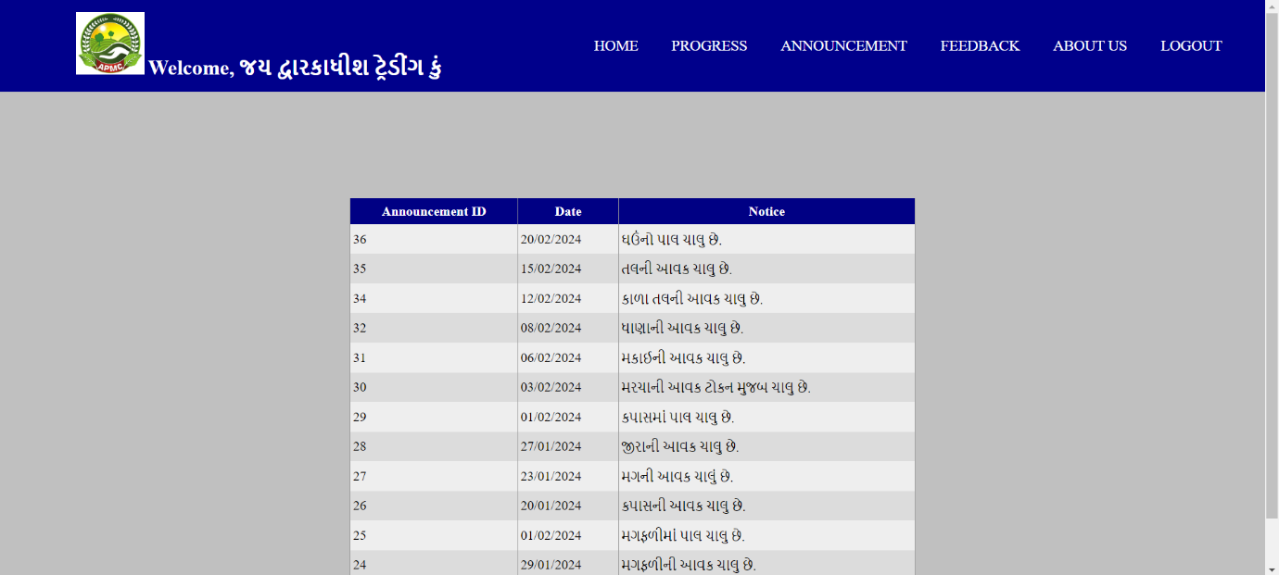

**Coding :-**

**:=>Annoucement.aspx**

<%@ Page Language="C#" MasterPageFile="~/C.A/MasterPage.master" AutoEventWireup="true" CodeFile="Annaucement.aspx.cs" Inherits="_Default" Title="Untitled Page" %>

<asp:Content ID="Content1" ContentPlaceHolderID="head" Runat="Server">

</asp:Content>

<asp:Content ID="Content2" ContentPlaceHolderID="ContentPlaceHolder1" Runat="Server">

<br />

<br />

<br />

<asp:GridView ID="GridViewAnnouncements" runat="server"

AutoGenerateColumns="False" DataKeyNames="AnnouncementId" BackColor="White"

BorderColor="#999999" BorderStyle="None" BorderWidth="1px" CellPadding="3"

Height="221px" Width="507px" HorizontalAlign="Center" GridLines="Vertical">

<RowStyle BackColor="#EEEEEE" ForeColor="Black" />

<Columns>

<asp:BoundField DataField="AnnouncementId" HeaderText="Announcement ID" SortExpression="AnnouncementId" ReadOnly="True" />

<asp:BoundField DataField="Date" HeaderText="Date" SortExpression="Date" />

<asp:BoundField DataField="Notice" HeaderText="Notice" SortExpression="Notice" />

</Columns>

<FooterStyle BackColor="#CCCCCC" ForeColor="Black" />

<PagerStyle BackColor="#999999" ForeColor="Black" HorizontalAlign="Center" />

<SelectedRowStyle BackColor="#008A8C" Font-Bold="True" ForeColor="White" />

<HeaderStyle BackColor="#000084" Font-Bold="True" ForeColor="White" />

<AlternatingRowStyle BackColor="#DCDCDC" />

</asp:GridView>

</asp:Content>

**:=>Annoucement.aspx.cs**

using System;

using System.Collections;

using System.Configuration;

using System.Data;

using System.Linq;

using System.Web;

using System.Web.Security;

using System.Web.UI;

using System.Web.UI.HtmlControls;

using System.Web.UI.WebControls;

using System.Web.UI.WebControls.WebParts;

using System.Xml.Linq;

using System.Data.SqlClient;

public partial class _Default : System.Web.UI.Page

{

string cs = ConfigurationManager.ConnectionStrings["welcome"].ConnectionString;

protected void Page_Load(object sender, EventArgs e)

{

if (!IsPostBack)

{

BindGridView();

}

}

private void BindGridView()

{

using (SqlConnection con = new SqlConnection(cs))

{

con.Open();

string query = "SELECT AnnouncementId, Date, Notice FROM Annoucement";

using (SqlCommand cmd = new SqlCommand(query, con))

{

SqlDataReader reader = cmd.ExecuteReader();

GridViewAnnouncements.DataSource = reader;

GridViewAnnouncements.DataBind();

}

}

}

}

**Feedback.aspx**

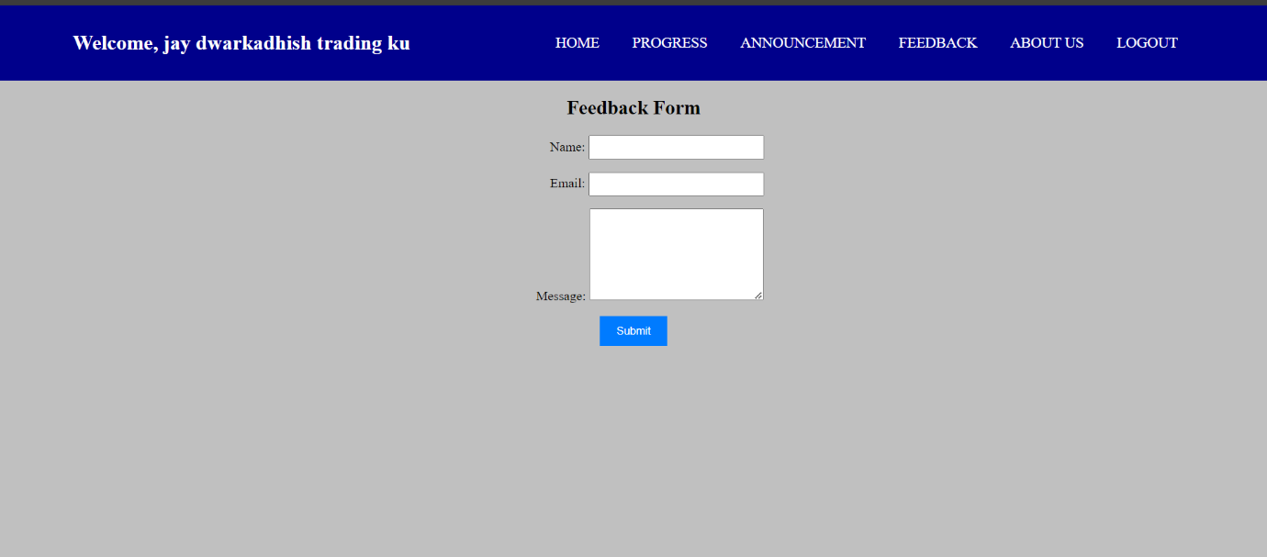

**Coding :-**

**:=>Feedback.aspx**

<%@ Page Language="C#" MasterPageFile="~/C.A/MasterPage.master" AutoEventWireup="true" CodeFile="Feedback.aspx.cs" Inherits="Feedback" Title="Feedback Page" %>

<asp:Content ID="Content1" ContentPlaceHolderID="head" Runat="Server">

<style>

.container {

width: 50%;

margin: 0 auto;

text-align: center;

}

.form-group {

margin-bottom: 15px;

}

.form-label {

display: inline-block;

width: 100px;

text-align: right;

}

.form-input {

width: 200px;

padding: 5px;

}

.form-message {

width: 200px;

height: 100px;

padding: 5px;

}

.form-submit {

padding: 10px 20px;

background-color: #007bff;

color: #fff;

border: none;

cursor: pointer;

}

.form-submit:hover {

background-color: #0056b3;

}

</style>

</asp:Content>

<asp:Content ID="Content2" ContentPlaceHolderID="ContentPlaceHolder1" Runat="Server">

<div class="container">

<h2>Feedback Form</h2>

<div class="form-group">

<label class="form-label" for="txtName">Name:</label>

<asp:TextBox ID="txtName" CssClass="form-input" runat="server" MaxLength="10" />

</div>

<div class="form-group">

<label class="form-label" for="txtEmail">Email:</label>

<asp:TextBox ID="txtEmail" CssClass="form-input" runat="server"

MaxLength="40" />

</div>

<div class="form-group">

<label class="form-label" for="txtMessage">Message:</label>

<asp:TextBox ID="txtMessage" CssClass="form-message" TextMode="MultiLine"

Rows="4" runat="server" MaxLength="100" />

</div>

<div class="form-group">

<asp:Button ID="btnSubmit" CssClass="form-submit" Text="Submit" OnClick="btnSubmit_Click" runat="server" />

</div>

</div>

</asp:Content>

**:=>Feedback.aspx.cs**

using System;

using System.Collections;

using System.Configuration;

using System.Data;

using System.Linq;

using System.Web;

using System.Web.Security;

using System.Web.UI;

using System.Web.UI.HtmlControls;

using System.Web.UI.WebControls;

using System.Web.UI.WebControls.WebParts;

using System.Xml.Linq;

using System.Data.SqlClient;

public partial class Feedback : System.Web.UI.Page

{

protected void Page_Load(object sender, EventArgs e)

{

}

protected void btnSubmit_Click(object sender, EventArgs e)

{

string name = txtName.Text;

string email = txtEmail.Text;

string message = txtMessage.Text;

string connectionString = ConfigurationManager.ConnectionStrings["welcome"].ConnectionString;

using (SqlConnection connection = new SqlConnection(connectionString))

{

connection.Open();

string query = "INSERT INTO Feedback (Name, Email, Message) VALUES (@Name, @Email, @Message)";

using (SqlCommand command = new SqlCommand(query, connection))

{

command.Parameters.AddWithValue("@Name", name);

command.Parameters.AddWithValue("@Email", email);

command.Parameters.AddWithValue("@Message", message);

command.ExecuteNonQuery();

}

}

}

}

**Aboutus.aspx**

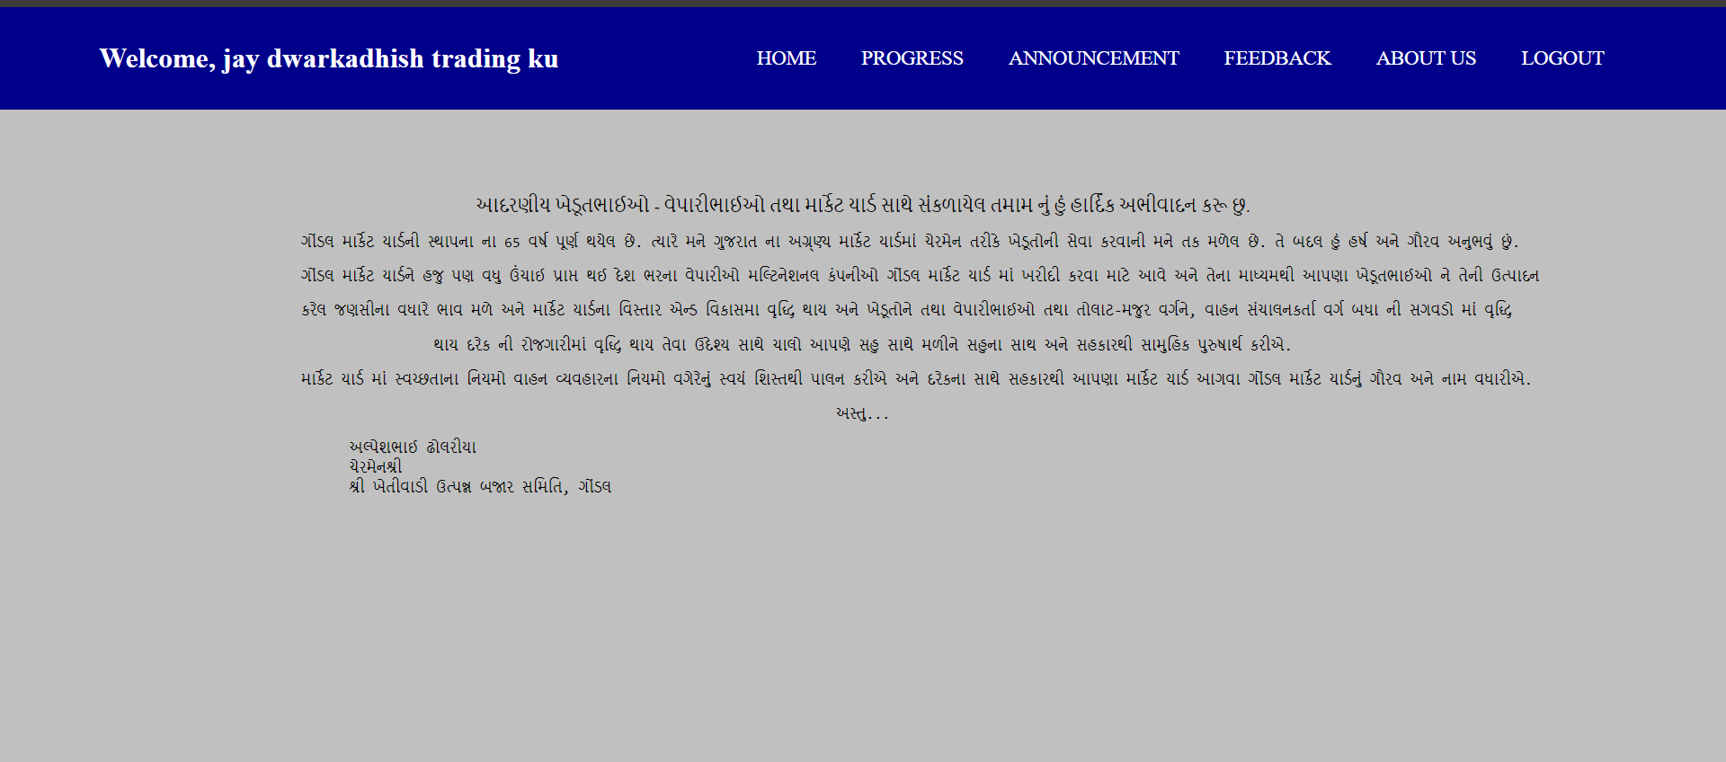

**Coding :-**

**:=>Aboutus.aspx**

<%@ Page Language="C#" MasterPageFile="~/C.A/MasterPage.master" AutoEventWireup="true" CodeFile="AboutUs.aspx.cs" Inherits="_Default" Title="Untitled Page" %>

<asp:Content ID="Content1" ContentPlaceHolderID="head" Runat="Server">

</asp:Content>

<asp:Content ID="Content2" ContentPlaceHolderID="ContentPlaceHolder1" Runat="Server">

<br />

<br />

<br />

<br />

<style>

.three{

display: flex;

align-items: center;

justify-content: center;

}

.about

{

width: 1000px;

text-align: center;

}

.two{

text-align: left;

}

</style>

<div class="three">

<div class="about">

<div>આદરણીય ખેડૂતભાઈઓ - વેપારીભાઈઓ તથા માર્કેટ યાર્ડ સાથે સંકળાયેલ તમામ નું હું હાર્દિક અભીવાદન કરૂ છુ.</div>

<pre>ગોંડલ માર્કેટ યાર્ડની સ્થાપના ના 65 વર્ષ પૂર્ણ થયેલ છે. ત્યારે મને ગુજરાત ના અગ્ર્ણ્ય માર્કેટ યાર્ડમાં ચેરમેન તરીકે ખેડૂતોની સેવા કરવાની મને તક મળેલ છે. તે બદલ હું હર્ષ અને ગૌરવ અનુભવું છું.</pre>

<pre>ગોંડલ માર્કેટ યાર્ડને હજુ પણ વધુ ઉંચાઈ પ્રાપ્ત થઈ દેશ ભરના વેપારીઓ મલ્ટિનેશનલ કંપનીઓ ગોંડલ માર્કેટ યાર્ડ માં ખરીદી કરવા માટે આવે અને તેના માધ્યમથી આપણા ખેડૂતભાઈઓ ને તેની ઉત્પાદન</pre>

<pre>કરેલ જણસીના વધારે ભાવ મળે અને માર્કેટ યાર્ડના વિસ્તાર એન્ડ વિકાસમા વૃદ્ધિ થાય અને ખેડૂતોને તથા વેપારીભાઈઓ તથા તોલાટ-મજુર વર્ગને, વાહન સંચાલનકર્તા વર્ગ બધા ની સગવડો માં વૃદ્ધિ </pre>

<pre>થાય દરેક ની રોજગારીમાં વૃદ્ધિ થાય તેવા ઉદેશ્ય સાથે ચાલો આપણે સહુ સાથે મળીને સહુના સાથ અને સહકારથી સામુહિક પુરુષાર્થ કરીએ.</pre>

<div></div>

<pre>માર્કેટ યાર્ડ માં સ્વચ્છતાના નિયમો વાહન વ્યવહારના નિયમો વગેરેનું સ્વયં શિસ્તથી પાલન કરીએ અને દરેકના સાથે સહકારથી આપણા માર્કેટ યાર્ડ આગવા ગોંડલ માર્કેટ યાર્ડનું ગૌરવ અને નામ વધારીએ.</pre>

<pre>અસ્તુ...</pre>

<pre class="two">

અલ્પેશભાઈ ઢોલરીયા

ચેરમેનશ્રી

શ્રી ખેતીવાડી ઉત્પન્ન બજાર સમિતિ, ગોંડલ

</pre>

</div>

</div>

</asp:Content>e

**:=>Aboutus.aspx.cs**

using System;

using System.Collections;

using System.Configuration;

using System.Data;

using System.Linq;

using System.Web;

using System.Web.Security;

using System.Web.UI;

using System.Web.UI.HtmlControls;

using System.Web.UI.WebControls;

using System.Web.UI.WebControls.WebParts;

using System.Xml.Linq;

public partial class _Default : System.Web.UI.Page

{

protected void Page_Load(object sender, EventArgs e)

{

}

}

* **ADMIN SIDE**

**Home.aspx**



**Coding :-**

**:=>Home.aspx**

<%@ Page Language="C#" MasterPageFile="~/Admin/AdminMasterPage.master" AutoEventWireup="true" CodeFile="Home.aspx.cs" Inherits="Admin_Default" Title="Untitled Page" %>

<asp:Content ID="Content1" ContentPlaceHolderID="head" Runat="Server">

</asp:Content>

<asp:Content ID="Content2" ContentPlaceHolderID="ContentPlaceHolder1" Runat="Server">

<img src="../img/farmer.jpeg.jpg" height="80%" width="100%"/>

</asp:Content>

**:=>**[**Home.aspx.cs**](http://Home.aspx.cs)

using System;

using System.Collections;

using System.Configuration;

using System.Data;

using System.Linq;

using System.Web;

using System.Web.Security;

using System.Web.UI;

using System.Web.UI.HtmlControls;

using System.Web.UI.WebControls;

using System.Web.UI.WebControls.WebParts;

using System.Xml.Linq;

public partial class Admin_Default : System.Web.UI.Page

{

protected void Page_Load(object sender, EventArgs e)

{

}

}

**:=>AdminMasterPage.master**

<%@ Master Language="C#" AutoEventWireup="true" CodeFile="AdminMasterPage.master.cs" Inherits="Admin_MasterPage" %>

<!DOCTYPE html PUBLIC "-//W3C//DTD XHTML 1.0 Transitional//EN" "http://www.w3.org/TR/xhtml1/DTD/xhtml1-transitional.dtd">

<html xmlns="http://www.w3.org/1999/xhtml">

<head runat="server">

<title>Untitled Page</title>

<asp:ContentPlaceHolder id="head" runat="server">

</asp:ContentPlaceHolder>

<style>

body{

margin: 0px;

padding:0px;

background-color: Silver;

}

.welcome {

font-size: 25px;

color: white;

margin-top: 10px;

font-weight: bold;

}

nav{

background-color:#990000;

display: flex;

justify-content: space-around;

align-items: center;

padding: 15px 30px;

}

nav h2{

color: white;

}

nav ul{

display: flex;

justify-content: center;

align-items: center;

}

nav ul li{

list-style: none;

padding: 4px 20px;

justify-content: space-around;

}

nav ul li a{

color: white;

font-size: 18px;

text-decoration: none;

}

</style>

</head>

<body>

<form id="form1" runat="server" enableviewstate="True">

<div class="hardik">

<div class="header">

<nav>

<div class="user-welcome">

<asp:Label ID="lblWelcome" runat="server" CssClass="welcome"></asp:Label>

</div>

<ul>

<li><a href="Home.aspx">HOME</a> </li>

<li><a href="Progress.aspx">PROGRESS</a> </li>

<li><a href="Crop.aspx">CROP</a> </li>

<li><a href="Admin.aspx">ADMIN</a> </li>

<li><a href="ca.aspx">COMMISSION AGENT</a> </li>

<li><a href="Annaucement.aspx">ANNOUNCEMENT</a> </li>

<li><a href="Feedback.aspx">FEEDBACK</a> </li>

<li><a href="Logout.aspx">LOGOUT</a> </li>

</ul>

</nav>

</div>

<div class="content">

<asp:ContentPlaceHolder id="ContentPlaceHolder1" runat="server">

</asp:ContentPlaceHolder>

</div>

<div class="footer">

</div>

</div>

</form>

</body>

</html>

**:=>AdminMasterPage.master.cs**

using System;

using System.Collections;

using System.Configuration;

using System.Data;

using System.Linq;

using System.Web;

using System.Web.Security;

using System.Web.UI;

using System.Web.UI.WebControls;

using System.Web.UI.WebControls.WebParts;

using System.Web.UI.HtmlControls;

using System.Xml.Linq;

public partial class Admin_MasterPage : System.Web.UI.MasterPage

{

protected void Page_Load(object sender, EventArgs e)

{

if (Session["Email"] != null)

{

string email = Session["Email"].ToString();

lblWelcome.Text = "Welcome, " + email;

}

else

{

Response.Redirect("Home.aspx");

}

}

}

**Progress.aspx**

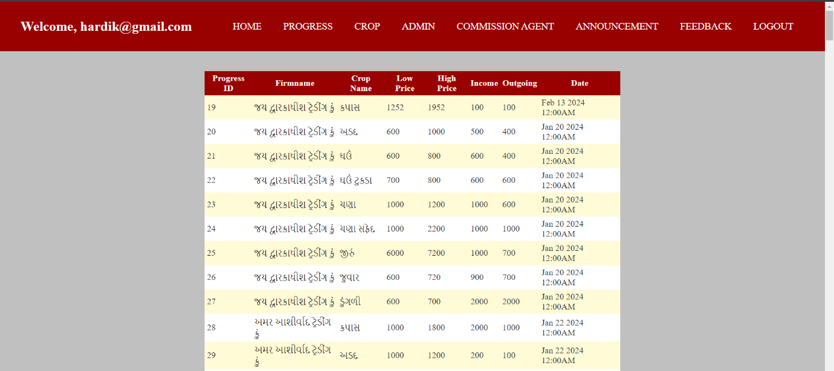

**Coding :-**

**:=>Progress.aspx**

<%@ Page Language="C#" MasterPageFile="~/Admin/AdminMasterPage.master" AutoEventWireup="true" CodeFile="Progress.aspx.cs" Inherits="Admin_Default" Title="Untitled Page" %>

<asp:Content ID="Content1" ContentPlaceHolderID="head" Runat="Server">

</asp:Content>

<asp:Content ID="Content2" ContentPlaceHolderID="ContentPlaceHolder1" Runat="Server">

<br />

<br />

<asp:GridView ID="GridView1" runat="server" AutoGenerateColumns="False"

OnRowDataBound="GridView1_RowDataBound" CellPadding="4"

Height="236px" Width="765px" HorizontalAlign="Center"

onselectedindexchanged="GridView1_SelectedIndexChanged" ForeColor="#333333"

GridLines="None">

<RowStyle BackColor="#FFFBD6" ForeColor="#333333" />

<Columns>

<asp:BoundField DataField="ProgressId" HeaderText="Progress ID" SortExpression="ProgressId" />

<asp:BoundField DataField="Firmname" HeaderText="Firmname" SortExpression="Firmname" />

<asp:BoundField DataField="CropName" HeaderText="Crop Name" SortExpression="CropName" />

<asp:BoundField DataField="LowPrice" HeaderText="Low Price" SortExpression="LowPrice" />

<asp:BoundField DataField="HighPrice" HeaderText="High Price" SortExpression="HighPrice" />

<asp:BoundField DataField="Income" HeaderText="Income" SortExpression="Income" />

<asp:BoundField DataField="Outgoing" HeaderText="Outgoing" SortExpression="Outgoing" />

<asp:BoundField DataField="Date" HeaderText="Date" SortExpression="Date" />

</Columns>

<FooterStyle BackColor="#990000" ForeColor="White" Font-Bold="True" />

<PagerStyle BackColor="#FFCC66" ForeColor="#333333" HorizontalAlign="Center" />

<SelectedRowStyle BackColor="#FFCC66" Font-Bold="True" ForeColor="Navy" />

<HeaderStyle BackColor="#990000" Font-Bold="True" ForeColor="White" />

<AlternatingRowStyle BackColor="White" />

</asp:GridView>

</asp:Content>

**:=>Progress.aspx.cs**

using System;

using System.Collections;

using System.Configuration;

using System.Data;

using System.Linq;

using System.Web;

using System.Web.Security;

using System.Web.UI;

using System.Web.UI.HtmlControls;

using System.Web.UI.WebControls;

using System.Web.UI.WebControls.WebParts;

using System.Xml.Linq;

using System.Data.SqlClient;

public partial class Admin_Default : System.Web.UI.Page

{

string cs = ConfigurationManager.ConnectionStrings["welcome"].ConnectionString;

protected void Page_Load(object sender, EventArgs e)

{

if (!IsPostBack)

{

BindGridView();

}

}

void BindGridView()

{

using (SqlConnection con = new SqlConnection(cs))

{

string query = @"SELECT p.ProgressId, p.CropName, p.LowPrice, p.HighPrice, p.Income, p.Outgoing, p.Date, u.Firmname

FROM Progress p

INNER JOIN [User] u ON p.UserId = u.UserId";

SqlDataAdapter sda = new SqlDataAdapter(query, con);

DataTable dt = new DataTable();

sda.Fill(dt);

GridView1.DataSource = dt;

GridView1.DataBind();

}

}

protected void GridView1_RowDataBound(object sender, GridViewRowEventArgs e)

{

}

protected void GridView1_SelectedIndexChanged(object sender, EventArgs e)

{

}

}

**Crop.aspx**

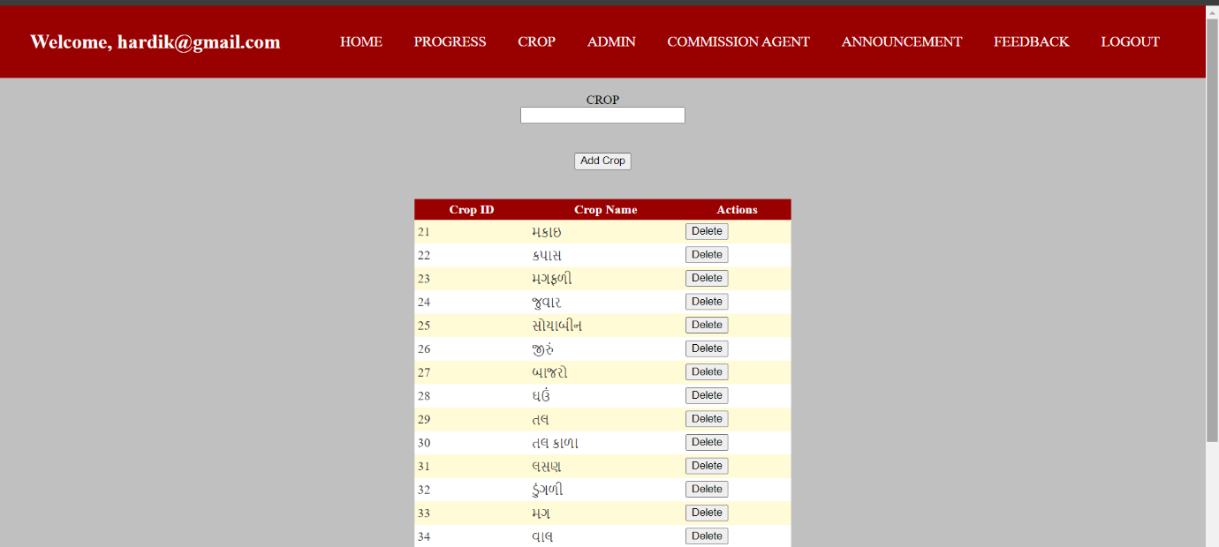

**Coding :-**

**:=>Crop.aspx**

<%@ Page Language="C#" MasterPageFile="~/Admin/AdminMasterPage.master" AutoEventWireup="true" CodeFile="Crop.aspx.cs" Inherits="Admin_Default" Title="Untitled Page" %>

<asp:Content ID="Content1" ContentPlaceHolderID="head" Runat="Server">

<style>

.input-group {

text-align: center;

display: flex;

flex-direction: column;

align-items: center;

justify-content: center;

}

.input-group input[type="text"],

.input-group input[type="password"] {

width: 200px;

}

.input-group button {

width: auto;

padding: 8px 20px;

}

</style>

</asp:Content>

<asp:Content ID="Content2" ContentPlaceHolderID="ContentPlaceHolder1" Runat="Server">

<div class="input-group">

<br />

<asp:Label ID="Label1" runat="server" Text="CROP"></asp:Label>

<asp:TextBox ID="TextBox1" runat="server" MaxLength="10"></asp:TextBox>

<br />

<br />

<asp:Button ID="Button1" runat="server" Text="Add Crop" OnClick="Button1_Click" />

</div>

<br />

<br />

<asp:GridView ID="GridView1" runat="server" DataKeyNames="CropId"

OnRowEditing="GridView1_RowEditing" OnRowCancelingEdit="GridView1_RowCancelingEdit"

OnRowUpdating="GridView1_RowUpdating"

OnRowDeleting="GridView1_RowDeleting" AutoGenerateColumns="False"

CellPadding="4" Height="246px" Width="475px" HorizontalAlign="Center"

ForeColor="#333333" GridLines="None">

<Columns>

<asp:BoundField DataField="CropId" HeaderText="Crop ID" ReadOnly="True" />

<asp:TemplateField HeaderText="Crop Name">

<ItemTemplate>

<asp:Label ID="lblCropName" runat="server" Text='<%# Bind("CropName") %>'></asp:Label>

</ItemTemplate>

<EditItemTemplate>

<asp:TextBox ID="txtCropName" runat="server" Text='<%# Bind("CropName") %>'></asp:TextBox>

</EditItemTemplate>

</asp:TemplateField>

<asp:CommandField ShowDeleteButton="True" ButtonType="Button" HeaderText="Actions" />

</Columns>

<RowStyle BackColor="#FFFBD6" ForeColor="#333333" />

<FooterStyle BackColor="#990000" ForeColor="White" Font-Bold="True" />

<PagerStyle BackColor="#FFCC66" ForeColor="#333333" HorizontalAlign="Center" />

<SelectedRowStyle BackColor="#FFCC66" Font-Bold="True" ForeColor="Navy" />

<HeaderStyle BackColor="#990000" Font-Bold="True" ForeColor="White" />

<AlternatingRowStyle BackColor="White" />

</asp:GridView>

</asp:Content>

**:=>Crop.aspx.cs**

using System;

using System.Collections;

using System.Configuration;

using System.Data;

using System.Linq;

using System.Web;

using System.Web.Security;

using System.Web.UI;

using System.Web.UI.HtmlControls;

using System.Web.UI.WebControls;

using System.Web.UI.WebControls.WebParts;

using System.Xml.Linq;

using System.Data.SqlClient;

public partial class Admin_Default : System.Web.UI.Page

{

string cs = ConfigurationManager.ConnectionStrings["welcome"].ConnectionString;

protected void Page_Load(object sender, EventArgs e)

{

if (!IsPostBack)

{

BindGridView();

}

}

private void BindGridView()

{

using (SqlConnection con = new SqlConnection(cs))

{

con.Open();

string query = "SELECT CropId, Cropname FROM Crop";

using (SqlCommand cmd = new SqlCommand(query, con))

{

SqlDataReader reader = cmd.ExecuteReader();

GridView1.DataSource = reader;

GridView1.DataBind();

}

}

}

protected void Button1_Click(object sender, EventArgs e)

{

string cropName = TextBox1.Text.Trim();

if (!string.IsNullOrEmpty(cropName))

{

AddCropToDatabase(cropName);

BindGridView();

TextBox1.Text = "";

}

else

{

}

}

private void AddCropToDatabase(string cropName)

{

using (SqlConnection con = new SqlConnection(cs))

{

con.Open();

string query = "INSERT INTO Crop (Cropname) VALUES (@CropName)";

using (SqlCommand cmd = new SqlCommand(query, con))

{

cmd.Parameters.AddWithValue("@CropName", cropName);

cmd.ExecuteNonQuery();

}

}

}

protected void GridView1_RowEditing(object sender, GridViewEditEventArgs e)

{

if (e.NewEditIndex >= 0 && e.NewEditIndex < GridView1.Rows.Count)

{

GridView1.EditIndex = e.NewEditIndex;

BindGridView();

}

}

protected void GridView1_RowCancelingEdit(object sender, GridViewCancelEditEventArgs e)

{

GridView1.EditIndex = -1;

BindGridView();

}

protected void GridView1_RowUpdating(object sender, GridViewUpdateEventArgs e)

{

GridViewRow row = GridView1.Rows[e.RowIndex];

int cropId = Convert.ToInt32(GridView1.DataKeys[e.RowIndex].Value);

TextBox txtCropName = (TextBox)row.FindControl("TextBox1");

if (txtCropName != null)

{

UpdateCropInDatabase(cropId, txtCropName.Text);

GridView1.EditIndex = -1;

BindGridView();

}

}

private void UpdateCropInDatabase(int cropId, string cropName)

{

using (SqlConnection con = new SqlConnection(cs))

{

con.Open();

string query = "UPDATE Crop SET Cropname = @CropName WHERE CropId = @CropId";

using (SqlCommand cmd = new SqlCommand(query, con))

{

cmd.Parameters.AddWithValue("@CropId", cropId);

cmd.Parameters.AddWithValue("@CropName", cropName);

cmd.ExecuteNonQuery();

}

}

}

protected void GridView1_RowDeleting(object sender, GridViewDeleteEventArgs e)

{

int rowIndex = e.RowIndex;

if (GridView1.DataKeys != null && rowIndex >= 0 && rowIndex < GridView1.Rows.Count)

{

int cropId = Convert.ToInt32(GridView1.DataKeys[rowIndex].Value);

DeleteCropFromDatabase(cropId);

BindGridView();

}

}

private void DeleteCropFromDatabase(int cropId)

{

using (SqlConnection con = new SqlConnection(cs))

{

con.Open();

string query = "DELETE FROM Crop WHERE CropId = @CropId";

using (SqlCommand cmd = new SqlCommand(query, con))

{

cmd.Parameters.AddWithValue("@CropId", cropId);

cmd.ExecuteNonQuery();

}

}

}

}

**Admin.aspx**

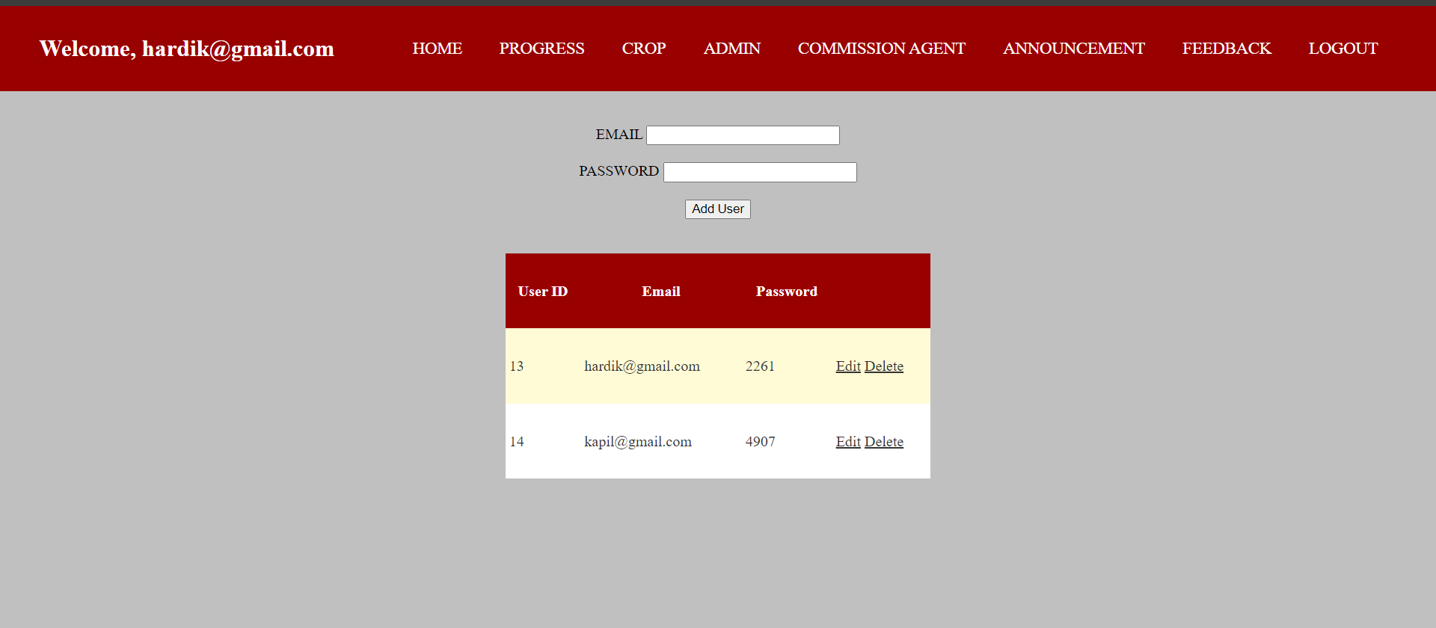

**Coding :-**

**:=>Admin.aspx**

<%@ Page Language="C#" MasterPageFile="~/Admin/AdminMasterPage.master" AutoEventWireup="true" CodeFile="Admin.aspx.cs" Inherits="Admin_Default" Title="Untitled Page" %>

<asp:Content ID="Content1" ContentPlaceHolderID="head" Runat="Server">

<style>

.input-group {

text-align: center;

}

.input-group input[type="text"],

.input-group input[type="password"] {

width: 200px;

}

.input-group button {

width: auto;

padding: 8px 20px;

}

</style>

</asp:Content>

<asp:Content ID="Content2" ContentPlaceHolderID="ContentPlaceHolder1" Runat="Server">

<br />

<div class="input-group">

<br />

<asp:Label ID="Label1" runat="server" Text="EMAIL"></asp:Label>

<asp:TextBox ID="TextBoxEmail" runat="server" MaxLength="40"></asp:TextBox>

<br />

<br />

</div>

<div class="input-group">

<asp:Label ID="Label2" runat="server" Text="PASSWORD"></asp:Label>

<asp:TextBox ID="TextBoxPassword" runat="server" TextMode="Password"

MaxLength="8"></asp:TextBox>

<br />

<br />

</div>

<div class="input-group">

<asp:Button ID="ButtonAdd" runat="server" Text="Add User" OnClick="ButtonAdd_Click" />

<br />

</div>

<br /><br />

<asp:GridView ID="GridViewUsers" runat="server" AutoGenerateColumns="False" DataKeyNames="UserId"

OnRowDeleting="GridViewUsers_RowDeleting" OnRowEditing="GridViewUsers_RowEditing"

OnRowCancelingEdit="GridViewUsers_RowCancelingEdit"

OnRowUpdating="GridViewUsers_RowUpdating" CellPadding="4"

Height="241px" Width="455px" HorizontalAlign="Center" ForeColor="#333333"

GridLines="None">

<RowStyle BackColor="#FFFBD6" ForeColor="#333333" />

<Columns>

<asp:BoundField DataField="UserId" HeaderText="User ID" ReadOnly="true" />

<asp:TemplateField HeaderText="Email">

<ItemTemplate>

<asp:Label ID="LabelEmail" runat="server" Text='<%# Eval("Email") %>'></asp:Label>

</ItemTemplate>

<EditItemTemplate>

<asp:TextBox ID="TextBoxEmail_Edit" runat="server" Text='<%# Bind("Email") %>'></asp:TextBox>

</EditItemTemplate>

</asp:TemplateField>

<asp:TemplateField HeaderText="Password">

<ItemTemplate>

<asp:Label ID="LabelPassword" runat="server" Text='<%# Eval("Password") %>'></asp:Label>

</ItemTemplate>

<EditItemTemplate>

<asp:TextBox ID="TextBoxPassword_Edit" runat="server" Text='<%# Bind("Password") %>'></asp:TextBox>

</EditItemTemplate>

</asp:TemplateField>

<asp:CommandField ShowDeleteButton="True" ShowEditButton="True" />

</Columns>

<FooterStyle BackColor="#990000" ForeColor="White" Font-Bold="True" />

<PagerStyle BackColor="#FFCC66" ForeColor="#333333" HorizontalAlign="Center" />

<SelectedRowStyle BackColor="#FFCC66" Font-Bold="True" ForeColor="Navy" />

<HeaderStyle BackColor="#990000" Font-Bold="True" ForeColor="White" />

<AlternatingRowStyle BackColor="White" />

</asp:GridView>

</asp:Content>

**:=>Admin.aspx.cs**

using System;

using System.Collections;

using System.Configuration;

using System.Data;

using System.Linq;

using System.Web;

using System.Web.Security;

using System.Web.UI;

using System.Web.UI.HtmlControls;

using System.Web.UI.WebControls;

using System.Web.UI.WebControls.WebParts;

using System.Xml.Linq;

using System.Data.SqlClient;

using System.Data.SqlClient;

public partial class Admin_Default : System.Web.UI.Page

{

string cs = ConfigurationManager.ConnectionStrings["welcome"].ConnectionString;

protected void Page_Load(object sender, EventArgs e)

{

if (!IsPostBack)

{

BindGridView();

}

}

private void BindGridView()

{

using (SqlConnection con = new SqlConnection(cs))

{

con.Open();

string query = "SELECT UserId, Email, Password FROM [User]WHERE UserType = 'Admin' ";

using (SqlCommand cmd = new SqlCommand(query, con))

{

SqlDataReader reader = cmd.ExecuteReader();

GridViewUsers.DataSource = reader;

GridViewUsers.DataBind();

}

}

}

protected void ButtonAdd_Click(object sender, EventArgs e)

{

string email = TextBoxEmail.Text.Trim();

string password = TextBoxPassword.Text.Trim();

if (!string.IsNullOrEmpty(email) && !string.IsNullOrEmpty(password))

{

AddUserToDatabase(email, password);

BindGridView();

TextBoxEmail.Text = "";

TextBoxPassword.Text = "";

}

else

{

}

}

private void AddUserToDatabase(string email, string password)

{

using (SqlConnection con = new SqlConnection(cs))

{

con.Open();

string query = "INSERT INTO [User] (Email, Password,UserType) VALUES (@Email, @Password,'Admin') ";

using (SqlCommand cmd = new SqlCommand(query, con))

{

cmd.Parameters.AddWithValue("@Email", email);

cmd.Parameters.AddWithValue("@Password", password);

cmd.ExecuteNonQuery();

}

}

}

protected void GridViewUsers_RowEditing(object sender, System.Web.UI.WebControls.GridViewEditEventArgs e)

{

GridViewUsers.EditIndex = e.NewEditIndex;

BindGridView();

}

protected void GridViewUsers_RowCancelingEdit(object sender, System.Web.UI.WebControls.GridViewCancelEditEventArgs e)

{

GridViewUsers.EditIndex = -1;

BindGridView();

}

protected void GridViewUsers_RowUpdating(object sender, System.Web.UI.WebControls.GridViewUpdateEventArgs e)

{

GridViewRow row = GridViewUsers.Rows[e.RowIndex];

int userId = Convert.ToInt32(GridViewUsers.DataKeys[e.RowIndex].Value);

TextBox txtEmail = (TextBox)row.FindControl("TextBoxEmail_Edit");

TextBox txtPassword = (TextBox)row.FindControl("TextBoxPassword_Edit");

if (txtEmail != null && txtPassword != null)

{

UpdateUserInDatabase(userId, txtEmail.Text, txtPassword.Text);

GridViewUsers.EditIndex = -1;

BindGridView();

}

}

private void UpdateUserInDatabase(int userId, string email, string password)

{

using (SqlConnection con = new SqlConnection(cs))

{

con.Open();

string query = "UPDATE [User] SET Email = @Email, Password = @Password WHERE UserId = @UserId";

using (SqlCommand cmd = new SqlCommand(query, con))

{

cmd.Parameters.AddWithValue("@UserId", userId);

cmd.Parameters.AddWithValue("@Email", email);

cmd.Parameters.AddWithValue("@Password", password);

cmd.ExecuteNonQuery();

}

}

}

protected void GridViewUsers_RowDeleting(object sender, System.Web.UI.WebControls.GridViewDeleteEventArgs e)

{

int rowIndex = e.RowIndex;

if (GridViewUsers.DataKeys != null && rowIndex >= 0 && rowIndex < GridViewUsers.Rows.Count)

{

int userId = Convert.ToInt32(GridViewUsers.DataKeys[rowIndex].Value);

DeleteUserFromDatabase(userId);

BindGridView();

}

}

private void DeleteUserFromDatabase(int userId)

{

using (SqlConnection con = new SqlConnection(cs))

{

con.Open();

string query = "DELETE FROM [User] WHERE UserId = @UserId";

using (SqlCommand cmd = new SqlCommand(query, con))

{

cmd.Parameters.AddWithValue("@UserId", userId);

cmd.ExecuteNonQuery();

}

}

}

}

**ca.aspx**

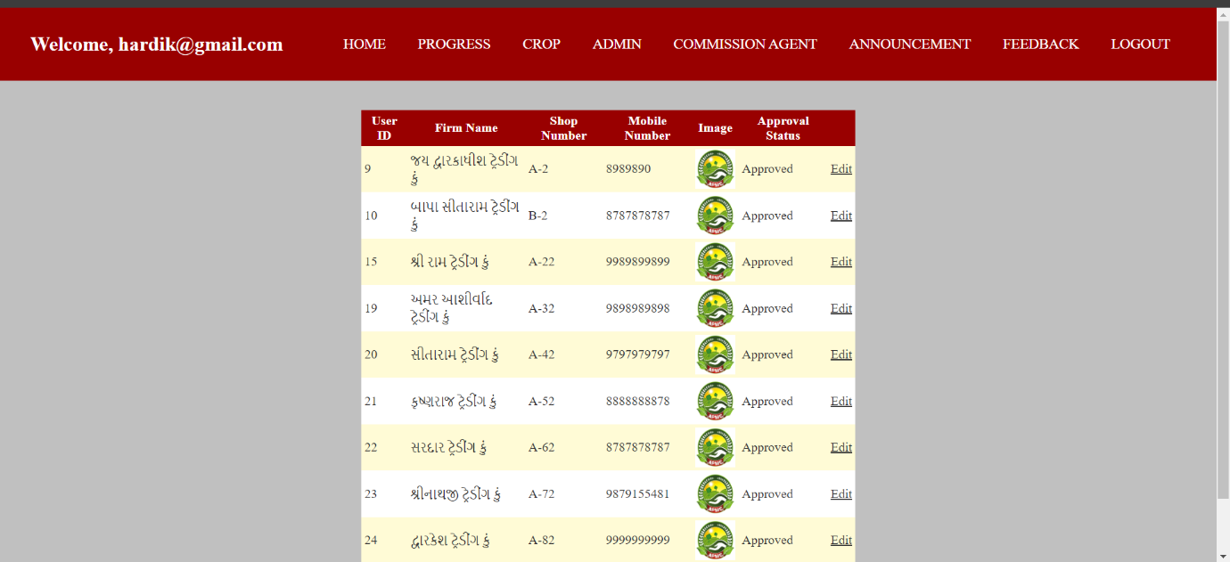

**Coding :-**

**:=>ca.aspx**

<%@ Page Language="C#" MasterPageFile="~/Admin/AdminMasterPage.master" AutoEventWireup="true" CodeFile="ca.aspx.cs" Inherits="Admin_Default" Title="Untitled Page" %>

<asp:Content ID="Content1" ContentPlaceHolderID="head" Runat="Server">

</asp:Content>

<asp:Content ID="Content2" ContentPlaceHolderID="ContentPlaceHolder1" Runat="Server">

<br />

<br />

<asp:GridView ID="GridView1" runat="server" AutoGenerateColumns="False" DataKeyNames="UserId"

CellPadding="4" Height="231px" Width="617px"

OnRowCommand="GridView1_RowCommand" OnRowEditing="GridView1_RowEditing"

OnRowCancelingEdit="GridView1_RowCancelingEdit"

OnRowUpdating="GridView1_RowUpdating" HorizontalAlign="Center"

ForeColor="#333333" GridLines="None">

<RowStyle BackColor="#FFFBD6" ForeColor="#333333" />

<Columns>

<asp:BoundField DataField="UserId" HeaderText="User ID" SortExpression="UserId" ReadOnly="true" />

<asp:BoundField DataField="Firmname" HeaderText="Firm Name" SortExpression="Firmname" ReadOnly="true" />

<asp:BoundField DataField="Shopnumber" HeaderText="Shop Number" SortExpression="Shopnumber" ReadOnly="true" />

<asp:BoundField DataField="Mobilenumber" HeaderText="Mobile Number" SortExpression="Mobilenumber" ReadOnly="true" />

<asp:TemplateField HeaderText="Approval Status">

<ItemTemplate>

<asp:Label ID="lblApprovalStatus" runat="server" Text='<%# GetApprovalStatusText(Eval("IsApproved")) %>'></asp:Label>

</ItemTemplate>

<EditItemTemplate>

<asp:RadioButton ID="ApproveRadioButton" runat="server" Text="Approve" GroupName="ApprovalGroup" Checked='<%# Convert.ToBoolean(Eval("IsApproved")) %>' />

<asp:RadioButton ID="RejectRadioButton" runat="server" Text="Reject" GroupName="ApprovalGroup" Checked='<%# !Convert.ToBoolean(Eval("IsApproved")) %>' />

</EditItemTemplate>

</asp:TemplateField>

<asp:CommandField ShowEditButton="True" />

<asp:ButtonField Text="Submit Approval"/>

</Columns>

<FooterStyle BackColor="#990000" ForeColor="White" Font-Bold="True" />

<PagerStyle BackColor="#FFCC66" ForeColor="#333333" HorizontalAlign="Center" />

<SelectedRowStyle BackColor="#FFCC66" Font-Bold="True" ForeColor="Navy" />

<HeaderStyle BackColor="#990000" Font-Bold="True" ForeColor="White" />

<AlternatingRowStyle BackColor="White" />

</asp:GridView>

<asp:Label ID="lblSubmissionStatus" runat="server" Text="" Visible="false" ForeColor="Green"></asp:Label>

</asp:Content>

**:=>ca.aspx.cs**

using System;

using System.Collections;

using System.Configuration;

using System.Data;

using System.Linq;

using System.Web;

using System.Web.Security;

using System.Web.UI;

using System.Web.UI.HtmlControls;

using System.Web.UI.WebControls;

using System.Web.UI.WebControls.WebParts;

using System.Xml.Linq;

using System.Data.SqlClient;

public partial class Admin_Default : System.Web.UI.Page

{

string cs = System.Configuration.ConfigurationManager.ConnectionStrings["welcome"].ConnectionString;

protected void Page_Load(object sender, EventArgs e)

{

if (!IsPostBack)

{

BindGridView();

}

}

private void BindGridView()

{

using (SqlConnection con = new SqlConnection(cs))

{

using (SqlCommand cmd = new SqlCommand("SELECT UserId, Firmname, Shopnumber, Mobilenumber, IsApproved FROM [User] WHERE UserType = @UserType", con))

{

cmd.Parameters.AddWithValue("@UserType", "User");

SqlDataAdapter da = new SqlDataAdapter(cmd);

DataTable dt = new DataTable();

da.Fill(dt);

GridView1.DataSource = dt;

GridView1.DataBind();

}

}

}

protected void GridView1_RowCommand(object sender, GridViewCommandEventArgs e)

{

if (e.CommandName == "SubmitApproval")

{

int rowIndex = Convert.ToInt32(e.CommandArgument);

if (rowIndex >= 0 && rowIndex < GridView1.Rows.Count)

{

RadioButton approveRadioButton = (RadioButton)GridView1.Rows[rowIndex].FindControl("ApproveRadioButton");

RadioButton rejectRadioButton = (RadioButton)GridView1.Rows[rowIndex].FindControl("RejectRadioButton");

int userId = Convert.ToInt32(GridView1.DataKeys[rowIndex].Values["UserId"]);

if (approveRadioButton.Checked)

{

UpdateApprovalStatus(userId, true);

}

else if (rejectRadioButton.Checked)

{

UpdateApprovalStatus(userId, false);

}

BindGridView();

}

else

{

}

}

}

protected string GetApprovalStatusText(object isApproved)

{

if (isApproved != null && isApproved != DBNull.Value)

{

bool approvalStatus = Convert.ToBoolean(isApproved);

return approvalStatus ? "Approved" : "Not Approved";

}

return "Unknown";

}

protected void GridView1_RowEditing(object sender, GridViewEditEventArgs e)

{

GridView1.EditIndex = e.NewEditIndex;

BindGridView();

}

protected void GridView1_RowCancelingEdit(object sender, GridViewCancelEditEventArgs e)

{

GridView1.EditIndex = -1;

BindGridView();

}

protected void GridView1_RowUpdating(object sender, GridViewUpdateEventArgs e)

{

string userId = GridView1.DataKeys[e.RowIndex].Value.ToString();

RadioButton approveRadioButton = (RadioButton)GridView1.Rows[e.RowIndex].FindControl("ApproveRadioButton");

RadioButton rejectRadioButton = (RadioButton)GridView1.Rows[e.RowIndex].FindControl("RejectRadioButton");

bool approvalStatus = approveRadioButton.Checked;

UpdateUserApprovalStatus(userId, approvalStatus);

GridView1.EditIndex = -1;

BindGridView();

lblSubmissionStatus.Text = "Update successful";

lblSubmissionStatus.Visible = true;

}

private void UpdateApprovalStatus(int userId, bool isApproved)

{

using (SqlConnection con = new SqlConnection(cs))

{

con.Open();

string query = "UPDATE [User] SET IsApproved = @IsApproved WHERE UserId = @UserId";

using (SqlCommand cmd = new SqlCommand(query, con))

{

cmd.Parameters.AddWithValue("@UserId", userId);

cmd.Parameters.AddWithValue("@IsApproved", isApproved);

cmd.ExecuteNonQuery();

}

}

}

private void UpdateUserApprovalStatus(string userId, bool isApproved)

{

try

{

using (SqlConnection con = new SqlConnection(cs))

{

con.Open();

string query = "UPDATE [User] SET IsApproved = @IsApproved WHERE UserId = @UserId";

using (SqlCommand cmd = new SqlCommand(query, con))

{

cmd.Parameters.AddWithValue("@UserId", userId);

cmd.Parameters.AddWithValue("@IsApproved", isApproved);

int rowsAffected = cmd.ExecuteNonQuery();

if (rowsAffected > 0)

{

Console.WriteLine("User {userId} approval status updated to {isApproved}");

}

else

{

Console.WriteLine("User {userId} approval status update failed");

}

}

}

}

catch (Exception ex)

{

Console.WriteLine("Error updating approval status: {ex.Message}");

}

}

}

**Announcement.aspx**

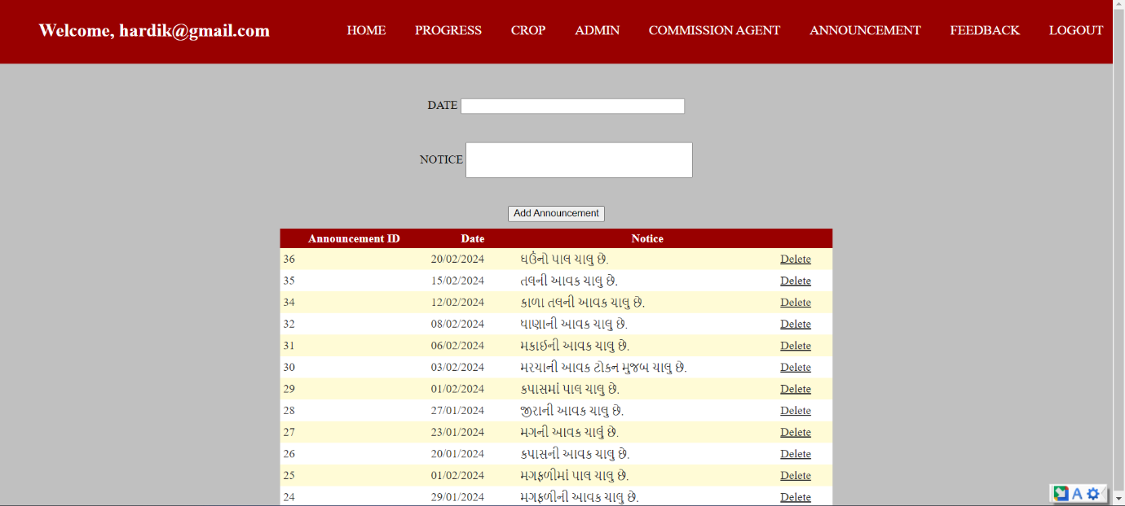

**Coding :-**

**:=>Announcement.aspx**

<%@ Page Language="C#" MasterPageFile="~/Admin/AdminMasterPage.master" AutoEventWireup="true" CodeFile="Annaucement.aspx.cs" Inherits="Admin_Default" Title="Add Announcement" %>

<asp:Content ID="Content1" ContentPlaceHolderID="head" Runat="Server">

<style>

.center-container {

text-align: center;

}

.input-group {

display: inline-block;

text-align: left;

margin: 10px;

}

.input-group input[type="text"],

.input-group input[type="password"] {

width: 200px;

}

.input-group button {

width: auto;

padding: 8px 20px;

}

</style>

</asp:Content>

<asp:Content ID="Content2" ContentPlaceHolderID="ContentPlaceHolder1" Runat="Server">

<div class="center-container">

<div class="input-group">

<br />

<asp:Label ID="LabelDate" runat="server" Text="DATE"></asp:Label>

<asp:TextBox ID="TextBoxDate" runat="server" Width="299px" MaxLength="10"></asp:TextBox>

</div>

<br />

<div class="input-group">

<br />

<asp:Label ID="LabelNotice" runat="server" Text="NOTICE"></asp:Label>

<asp:TextBox ID="TextBoxNotice" runat="server" Height="44px" Width="302px"

MaxLength="100"></asp:TextBox>

</div>

<br />

<br />

<div class="input-group">

<asp:Button ID="ButtonAddAnnouncement" runat="server" Text="Add Announcement" OnClick="ButtonAddAnnouncement_Click" />

<br />

</div>

</div>

<asp:GridView ID="GridViewAnnouncements" runat="server"

AutoGenerateColumns="False" DataKeyNames="AnnouncementId"

OnRowDeleting="GridViewAnnouncements_RowDeleting"

ShowHeaderWhenEmpty="True" CellPadding="4" Height="281px"

Width="673px" HorizontalAlign="Center" ForeColor="#333333"

GridLines="None">

<RowStyle BackColor="#FFFBD6" ForeColor="#333333" />

<Columns>

<asp:BoundField DataField="AnnouncementId" HeaderText="Announcement ID" SortExpression="AnnouncementId" ReadOnly="True" />

<asp:BoundField DataField="Date" HeaderText="Date" SortExpression="Date" />

<asp:BoundField DataField="Notice" HeaderText="Notice" SortExpression="Notice" />

<asp:CommandField ShowDeleteButton="True" />

</Columns>

<FooterStyle BackColor="#990000" ForeColor="White" Font-Bold="True" />

<PagerStyle BackColor="#FFCC66" ForeColor="#333333" HorizontalAlign="Center" />

<SelectedRowStyle BackColor="#FFCC66" Font-Bold="True" ForeColor="Navy" />

<HeaderStyle BackColor="#990000" Font-Bold="True" ForeColor="White" />

<AlternatingRowStyle BackColor="White" />

</asp:GridView>

</asp:Content>

**:=>Announcement.aspx.cs**

using System;

using System.Collections;

using System.Configuration;

using System.Data;

using System.Linq;

using System.Web;

using System.Web.Security;

using System.Web.UI;

using System.Web.UI.HtmlControls;

using System.Web.UI.WebControls;

using System.Web.UI.WebControls.WebParts;

using System.Xml.Linq;

using System.Data.SqlClient;

public partial class Admin_Default : System.Web.UI.Page

{

string cs = ConfigurationManager.ConnectionStrings["welcome"].ConnectionString;

protected void Page_Load(object sender, EventArgs e)

{

if (!IsPostBack)

{

BindGridView();

}

}

private void BindGridView()

{

using (SqlConnection con = new SqlConnection(cs))

{

con.Open();

string query = "SELECT AnnouncementId, Date, Notice FROM Annoucement";

using (SqlCommand cmd = new SqlCommand(query, con))

{

SqlDataReader reader = cmd.ExecuteReader();

GridViewAnnouncements.DataSource = reader;

GridViewAnnouncements.DataBind();

}

}

}

protected void ButtonAddAnnouncement_Click(object sender, EventArgs e)

{

string date = TextBoxDate.Text.Trim();

string notice = TextBoxNotice.Text.Trim();

if (!string.IsNullOrEmpty(date) && !string.IsNullOrEmpty(notice))

{

AddAnnouncementToDatabase(date, notice);

BindGridView();

TextBoxDate.Text = "";

TextBoxNotice.Text = "";

}

else

{

}

}

private void AddAnnouncementToDatabase(string date, string notice)

{

using (SqlConnection con = new SqlConnection(cs))

{

con.Open();

if (notice.Length <= 1000)

{

string query = "INSERT INTO Annoucement (Date, Notice) VALUES (@Date, @Notice)";

using (SqlCommand cmd = new SqlCommand(query, con))

{

cmd.Parameters.AddWithValue("@Date", date);

cmd.Parameters.AddWithValue("@Notice", notice);

cmd.ExecuteNonQuery();

}

}

else

{

}

}

}

protected void GridViewAnnouncements_RowDeleting(object sender, System.Web.UI.WebControls.GridViewDeleteEventArgs e)

{

int rowIndex = e.RowIndex;

if (GridViewAnnouncements.DataKeys != null && rowIndex >= 0 && rowIndex < GridViewAnnouncements.Rows.Count)

{

int announcementId = Convert.ToInt32(GridViewAnnouncements.DataKeys[rowIndex].Value);

DeleteAnnouncementFromDatabase(announcementId);

BindGridView();

}

}

private void DeleteAnnouncementFromDatabase(int announcementId)

{

using (SqlConnection con = new SqlConnection(cs))

{

con.Open();

string query = "DELETE FROM Annoucement WHERE AnnouncementId = @AnnouncementId";

using (SqlCommand cmd = new SqlCommand(query, con))

{

cmd.Parameters.AddWithValue("@AnnouncementId", announcementId);

cmd.ExecuteNonQuery();

}

}

}

}

**Feedback.aspx**

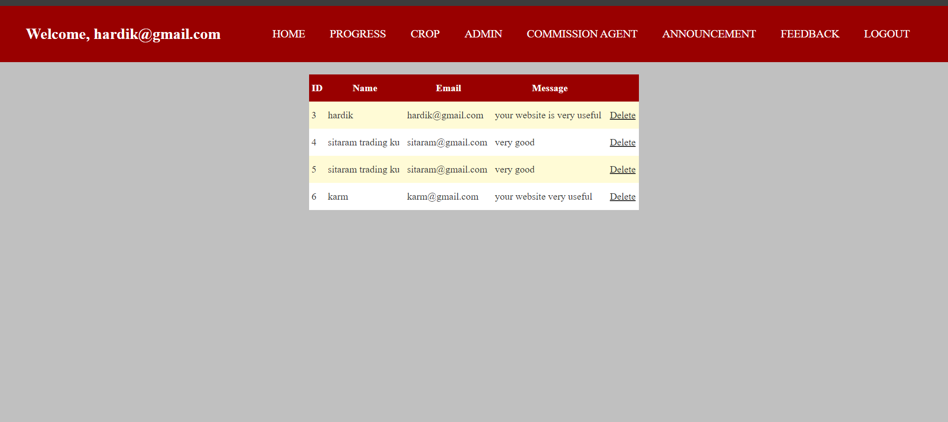

**Coding :-**

**:=>Feedback.aspx**

<%@ Page Language="C#" MasterPageFile="~/Admin/AdminMasterPage.master" AutoEventWireup="true" CodeFile="Feedback.aspx.cs" Inherits="Admin_Default" Title="Feedback Page" %>

<asp:Content ID="Content1" ContentPlaceHolderID="head" Runat="Server">

<style>

.feedback-grid {

margin: 20px;

}

</style>

</asp:Content>

<asp:Content ID="Content2" ContentPlaceHolderID="ContentPlaceHolder1" Runat="Server">

<div class="feedback-grid">

<asp:GridView ID="GridViewFeedback" runat="server" AutoGenerateColumns="False"

DataKeyNames="FeedbackID" CellPadding="4" Height="220px" Width="535px"

HorizontalAlign="Center" ForeColor="#333333" GridLines="None" OnRowDeleting="GridViewFeedback_RowDeleting">

<RowStyle BackColor="#FFFBD6" ForeColor="#333333" />

<Columns>

<asp:BoundField DataField="FeedbackID" HeaderText="ID" SortExpression="FeedbackID" />

<asp:BoundField DataField="Name" HeaderText="Name" SortExpression="Name" />

<asp:BoundField DataField="Email" HeaderText="Email" SortExpression="Email" />

<asp:BoundField DataField="Message" HeaderText="Message" SortExpression="Message" />

<asp:CommandField ShowDeleteButton="True" ButtonType="Link" DeleteText="Delete" />

</Columns>

<FooterStyle BackColor="#990000" Font-Bold="True" ForeColor="White" />

<PagerStyle BackColor="#FFCC66" ForeColor="#333333" HorizontalAlign="Center" />

<SelectedRowStyle BackColor="#FFCC66" Font-Bold="True" ForeColor="Navy" />

<HeaderStyle BackColor="#990000" Font-Bold="True" ForeColor="White" />

<AlternatingRowStyle BackColor="White" />

</asp:GridView>

</div>

</asp:Content>

**:=>Feedback.aspx.cs**

using System;

using System.Collections;

using System.Configuration;

using System.Data;

using System.Linq;

using System.Web;

using System.Web.Security;

using System.Web.UI;

using System.Web.UI.HtmlControls;

using System.Web.UI.WebControls;

using System.Web.UI.WebControls.WebParts;

using System.Xml.Linq;

using System.Data.SqlClient;

public partial class Admin_Default : System.Web.UI.Page

{

protected void Page_Load(object sender, EventArgs e)

{

if (!IsPostBack)

{

BindFeedbackData();

}

}

private void BindFeedbackData()

{

try

{

string connectionString = ConfigurationManager.ConnectionStrings["welcome"].ConnectionString;

using (SqlConnection connection = new SqlConnection(connectionString))

{

connection.Open();

string query = "SELECT FeedbackID, Name, Email, Message FROM Feedback";

SqlDataAdapter adapter = new SqlDataAdapter(query, connection);

DataTable dt = new DataTable();

adapter.Fill(dt);

GridViewFeedback.DataSource = dt;

GridViewFeedback.DataBind();

}

}

catch (Exception ex)

{

}

}

protected void GridViewFeedback_RowDeleting(object sender, GridViewDeleteEventArgs e)

{

try

{

int feedbackID = Convert.ToInt32(GridViewFeedback.DataKeys[e.RowIndex].Value);

string connectionString = ConfigurationManager.ConnectionStrings["welcome"].ConnectionString;

using (SqlConnection connection = new SqlConnection(connectionString))

{

connection.Open();

string query = "DELETE FROM Feedback WHERE FeedbackID = @FeedbackID";

SqlCommand cmd = new SqlCommand(query, connection);

cmd.Parameters.AddWithValue("@FeedbackID", feedbackID);

cmd.ExecuteNonQuery();

BindFeedbackData();

}

}

catch (Exception ex)

{

}

}

}

* **USER SIDE**

**Home.aspx**



**Coding :-**

**:=>Home.aspx**

<%@ Page Language="C#" MasterPageFile="~/User/Index.master" AutoEventWireup="true" CodeFile="Home.aspx.cs" Inherits="_Default" Title="Untitled Page" %>

<asp:Content ID="Content1" ContentPlaceHolderID="head" Runat="Server">

</asp:Content>

<asp:Content ID="Content2" ContentPlaceHolderID="ContentPlaceHolder1" Runat="Server">

<style>

body

{

background-color: gray;

}

.one

{

display: flex;

justify-content: center;

align-items: center;

margin-top:90px;

}

</style>

<div class="main">

<div class="one">

<img src="../img/apmclogo.jpeg.jpeg" width="1500px" height="535px"/>

</div>

</div>

</asp:Content>

**:=>**[**Home.aspx.cs**](http://Home.aspx.cs)

using System;

using System.Collections;

using System.Configuration;

using System.Data;

using System.Linq;

using System.Web;

using System.Web.Security;

using System.Web.UI;

using System.Web.UI.HtmlControls;

using System.Web.UI.WebControls;

using System.Web.UI.WebControls.WebParts;

using System.Xml.Linq;

public partial class _Default : System.Web.UI.Page

{

protected void Page_Load(object sender, EventArgs e)

{

}

}

**:=>Index.master**

<%@ Master Language="C#" AutoEventWireup="true" CodeFile="Index.master.cs" Inherits="Index" %>

<!DOCTYPE html PUBLIC "-//W3C//DTD XHTML 1.0 Transitional//EN" "http://www.w3.org/TR/xhtml1/DTD/xhtml1-transitional.dtd">

<html xmlns="http://www.w3.org/1999/xhtml">

<head runat="server">

<title>Untitled Page</title>

<asp:ContentPlaceHolder id="head" runat="server">

</asp:ContentPlaceHolder>

<style>

body {

margin: 0px;

padding: 0px;

background-color: silver;

padding-bottom: 60px;

}

nav {

background-color: #1C5E55;

display: flex;

justify-content: space-around;

align-items: center;

padding: 15px 30px;

position: fixed;

width: 100%;

top: 0;

z-index: 1000;

}

nav h2 {

color: white;

}

nav ul {

display: flex;

justify-content: center;

align-items: center;

}

nav ul li {

list-style: none;

padding: 4px 20px;

justify-content: space-around;

}

nav ul li a {

color: white;

font-size: 18px;

text-decoration: none;

}

footer {

position: fixed;

bottom: 0;

width: 100%;

background-color: #1C5E55;

color: white;

text-align: center;

padding: 10px 0;

}

</style>

</head>

<body>

<form id="form1" runat="server">

<div class="main">

<div class="header">

<nav>

<h2>WELCOME</h2>

<ul>

<li><a href="Home.aspx">HOME</a> </li>

<li><a href="Daily Progress.aspx">DAILY PROGRESS</a> </li>

<li><a href="Announcement.aspx">ANNOUNCEMENT</a> </li>

<li><a href="ca.aspx">COMMISSION AGENT</a> </li>

<li><a href="about.aspx">ABOUT US</a> </li>

<li><a href="Feedback.aspx">FEEDBACK</a> </li>

<li><a href="Login.aspx">LOGIN</a> </li>

<li><a href="Signup.aspx">SIGN UP</a> </li>

</ul>

</nav>

</div>

<div>

<asp:ContentPlaceHolder id="ContentPlaceHolder1" runat="server">

</asp:ContentPlaceHolder>

</div>

</div>

</form>

<footer>

<p>© All rights reserved by <b>hardik garaniya</b>,<b> kapil garaniya</b>, & <b>chintan garaniya</b></p>

</footer>

</body>

</html>

**:=>Index.master.cs**

using System;

using System.Collections;

using System.Configuration;

using System.Data;

using System.Linq;

using System.Web;

using System.Web.Security;

using System.Web.UI;

using System.Web.UI.WebControls;

using System.Web.UI.WebControls.WebParts;

using System.Web.UI.HtmlControls;

using System.Xml.Linq;

public partial class Index : System.Web.UI.MasterPage

{

protected void Page_Load(object sender, EventArgs e)

{

}

}

**Progress.aspx**

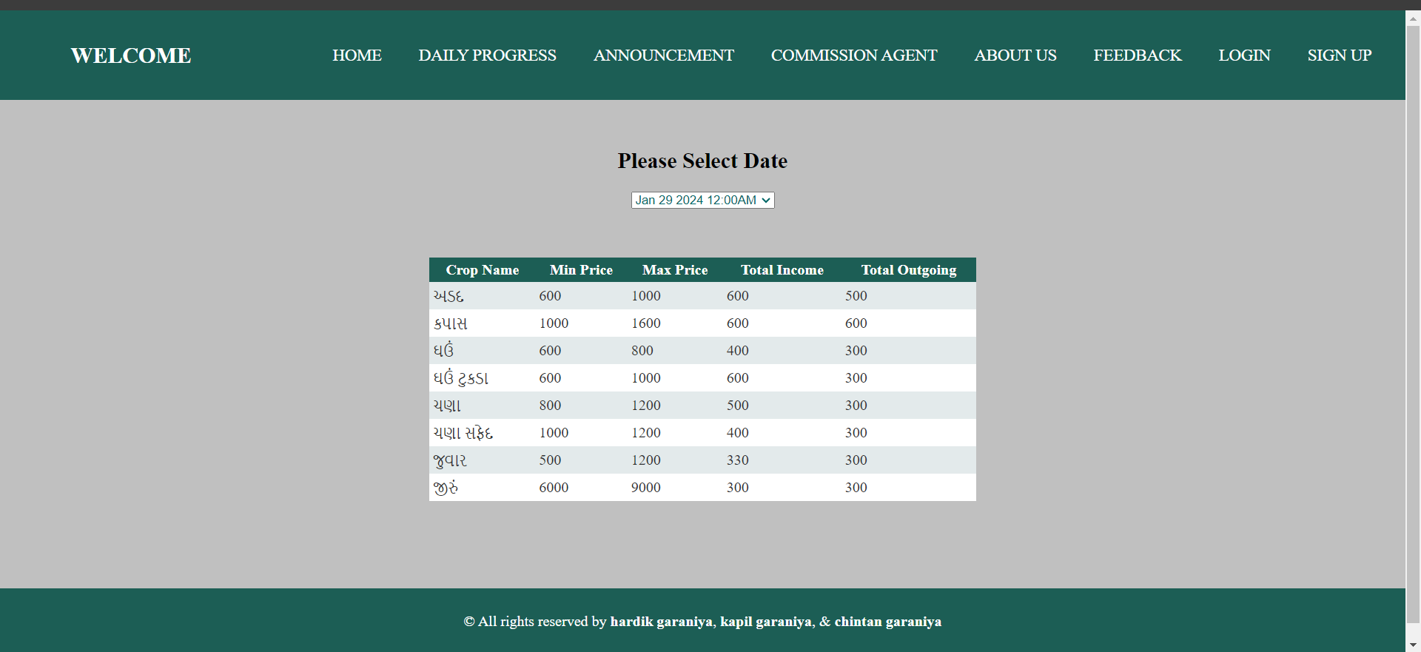

**Coding :-**

**:=>DailyProgress.aspx**

<%@ Page Language="C#" MasterPageFile="~/User/Index.master" AutoEventWireup="true" CodeFile="Daily Progress.aspx.cs" Inherits="_Default" Title="Untitled Page" %>

<asp:Content ID="Content1" ContentPlaceHolderID="head" Runat="Server">

<style>

h2{

text-align:center;

}

.c{

text-align:center;

}

</style>

</asp:Content>

<asp:Content ID="Content2" ContentPlaceHolderID="ContentPlaceHolder1" Runat="Server">

<br />

<br />

<br />

<br />

<br />

<br />

<br />

<h2>Please Select Date</h2>

<div class="c">

<asp:DropDownList ID="DropDownListDates" runat="server" AutoPostBack="true" OnSelectedIndexChanged="DropDownListDates_SelectedIndexChanged"

ForeColor="#006666">

</asp:DropDownList>

</div>

<br />

<br />

<p ALIGN="center">

<asp:GridView ID="GridView1" runat="server" AutoGenerateColumns="False"

CellPadding="4" ForeColor="#333333" GridLines="None" Height="191px"

Width="591px" HorizontalAlign="Center">

<RowStyle BackColor="#E3EAEB" />

<Columns>

<asp:BoundField DataField="CropName" HeaderText="Crop Name" SortExpression="CropName" />

<asp:BoundField DataField="MinPrice" HeaderText="Min Price" SortExpression="MinPrice" />

<asp:BoundField DataField="MaxPrice" HeaderText="Max Price" SortExpression="MaxPrice" />

<asp:BoundField DataField="TotalIncome" HeaderText="Total Income" SortExpression="TotalIncome" />

<asp:BoundField DataField="TotalOutgoing" HeaderText="Total Outgoing" SortExpression="TotalOutgoing" />

</Columns>

<FooterStyle BackColor="#1C5E55" ForeColor="White" Font-Bold="True" />

<PagerStyle BackColor="#666666" ForeColor="White" HorizontalAlign="Center" />

<SelectedRowStyle BackColor="#C5BBAF" Font-Bold="True" ForeColor="#333333" />

<HeaderStyle BackColor="#1C5E55" Font-Bold="True" ForeColor="White" />

<EditRowStyle BackColor="#7C6F57" />

<AlternatingRowStyle BackColor="White" />

</asp:GridView>

</p>

<p ALIGN="center">

&nbsp;</p>

<p ALIGN="center">

&nbsp;</p>

<br />

<br />

</asp:Content>

**:=>DailyProgress.aspx**

using System;

using System.Collections;

using System.Configuration;

using System.Data;

using System.Linq;

using System.Web;

using System.Web.Security;

using System.Web.UI;

using System.Web.UI.HtmlControls;

using System.Web.UI.WebControls;

using System.Web.UI.WebControls.WebParts;

using System.Xml.Linq;

using System.Data.SqlClient;

public partial class _Default : System.Web.UI.Page

{

string cs = ConfigurationManager.ConnectionStrings["welcome"].ConnectionString;

protected void Page_Load(object sender, EventArgs e)

{

if (!IsPostBack)

{

BindDateDropDown();

BindGridView();

}

}

private void BindDateDropDown()

{

using (SqlConnection con = new SqlConnection(cs))

{

con.Open();

string query = "SELECT DISTINCT Date FROM Progress";

using (SqlCommand cmd = new SqlCommand(query, con))

{

SqlDataAdapter da = new SqlDataAdapter(cmd);

DataTable dt = new DataTable();

da.Fill(dt);

DropDownListDates.DataSource = dt;

DropDownListDates.DataTextField = "Date";

DropDownListDates.DataValueField = "Date";

DropDownListDates.DataBind();

DropDownListDates.Items.Insert(0, new ListItem("Select Date", ""));

}

}

}

protected void DropDownListDates_SelectedIndexChanged(object sender, EventArgs e)

{

BindGridView();

}

private void BindGridView()

{

using (SqlConnection con = new SqlConnection(cs))

{

con.Open();

string selectedDate = DropDownListDates.SelectedValue;

string query = @"

SELECT

CropName,

MIN(LowPrice) AS MinPrice,

MAX(HighPrice) AS MaxPrice,

SUM(Income) AS TotalIncome,

SUM(Outgoing) AS TotalOutgoing

FROM

Progress

WHERE

Date = @selectedDate

GROUP BY

CropName;

";

using (SqlCommand cmd = new SqlCommand(query, con))

{

cmd.Parameters.AddWithValue("@selectedDate", selectedDate);

SqlDataAdapter da = new SqlDataAdapter(cmd);

DataTable dt = new DataTable();

da.Fill(dt);

GridView1.DataSource = dt;

GridView1.DataBind();

}

}

}

protected void btnSubmit_Click(object sender, EventArgs e)

{

BindGridView();

}

}

**Announcement.aspx**

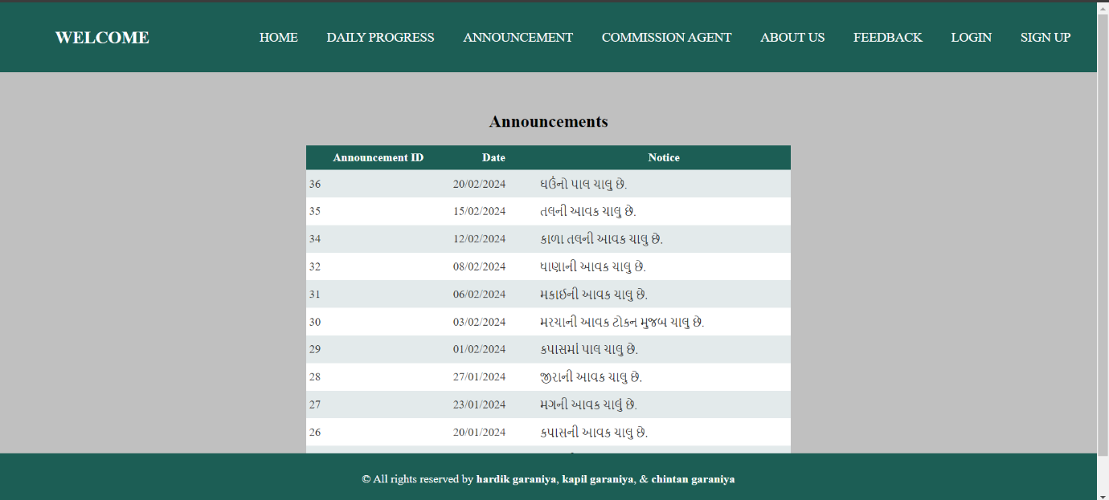

**Coding :-**

**:=>Announcement.aspx**

<%@ Page Language="C#" MasterPageFile="~/User/Index.master" AutoEventWireup="true" CodeFile="Announcement.aspx.cs" Inherits="_Default" Title="Untitled Page" %>

<asp:Content ID="Content1" ContentPlaceHolderID="head" Runat="Server">

<style>

h2{

text-align:center;

}

</style>

</asp:Content>

<asp:Content ID="Content2" ContentPlaceHolderID="ContentPlaceHolder1" Runat="Server">

<br />

<br />

<h2>Announcements</h2>

<asp:GridView ID="GridViewAnnouncements" runat="server"

AutoGenerateColumns="False" DataKeyNames="AnnouncementId" CellPadding="4"

ForeColor="#333333" GridLines="None" Height="213px" Width="437px"

HorizontalAlign="Center">

<RowStyle BackColor="#E3EAEB" />

<Columns>

<asp:BoundField DataField="AnnouncementId" HeaderText="Announcement ID" SortExpression="AnnouncementId" ReadOnly="True" />

<asp:BoundField DataField="Date" HeaderText="Date" SortExpression="Date" />

<asp:BoundField DataField="Notice" HeaderText="Notice" SortExpression="Notice" />

</Columns>

<FooterStyle BackColor="#1C5E55" ForeColor="White" Font-Bold="True" />

<PagerStyle BackColor="#666666" ForeColor="White" HorizontalAlign="Center" />

<SelectedRowStyle BackColor="#C5BBAF" Font-Bold="True" ForeColor="#333333" />

<HeaderStyle BackColor="#1C5E55" Font-Bold="True" ForeColor="White" />

<EditRowStyle BackColor="#7C6F57" />

<AlternatingRowStyle BackColor="White" />

</asp:GridView>

</asp:Content>

**:=>Announcement.aspx.cs**

using System;

using System.Collections;

using System.Configuration;

using System.Data;

using System.Linq;

using System.Web;

using System.Web.Security;

using System.Web.UI;

using System.Web.UI.HtmlControls;

using System.Web.UI.WebControls;

using System.Web.UI.WebControls.WebParts;

using System.Xml.Linq;

using System.Data.SqlClient;

public partial class _Default : System.Web.UI.Page

{

string cs = ConfigurationManager.ConnectionStrings["welcome"].ConnectionString;

protected void Page_Load(object sender, EventArgs e)

{

if (!IsPostBack)

{

BindGridView();

}

}

private void BindGridView()

{

using (SqlConnection con = new SqlConnection(cs))

{

con.Open();

string query = "SELECT AnnouncementId, Date, Notice FROM Annoucement";

using (SqlCommand cmd = new SqlCommand(query, con))

{

SqlDataReader reader = cmd.ExecuteReader();

GridViewAnnouncements.DataSource = reader;

GridViewAnnouncements.DataBind();

}

}

}

}

**ca.aspx**

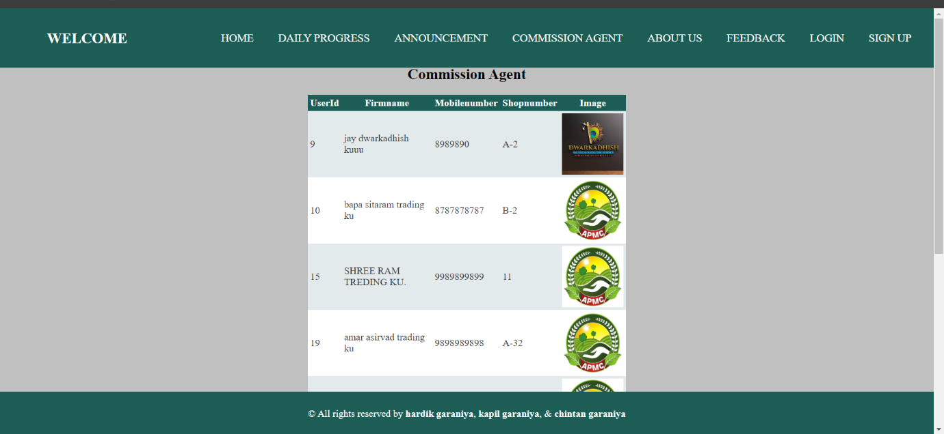

**Coding :-**

**:=>ca.aspx**

<%@ Page Language="C#" MasterPageFile="~/User/Index.master" AutoEventWireup="true" CodeFile="ca.aspx.cs" Inherits="User_Default" Title="Untitled Page" %>

<asp:Content ID="Content1" ContentPlaceHolderID="head" Runat="Server">

<style>

h2{

text-align:center;

}

</style>

</asp:Content>

<asp:Content ID="Content2" ContentPlaceHolderID="ContentPlaceHolder1" Runat="Server">

<br />

<br />

<br />

<br />

<h2>Commission Agent</h2>

<asp:GridView ID="GridView1" runat="server" AutoGenerateColumns="False"

CellPadding="4" ForeColor="#333333" GridLines="None"

Height="224px" Width="518px" HorizontalAlign="Center">

<Columns>

<asp:BoundField DataField="UserId" HeaderText="UserId" SortExpression="UserId" />

<asp:BoundField DataField="Firmname" HeaderText="Firmname" SortExpression="Firmname" />

<asp:BoundField DataField="Mobilenumber" HeaderText="Mobilenumber" SortExpression="Mobilenumber" />

<asp:BoundField DataField="Shopnumber" HeaderText="Shopnumber" SortExpression="Shopnumber" />

</Columns>

<RowStyle BackColor="#E3EAEB" />

<FooterStyle BackColor="#1C5E55" ForeColor="White" Font-Bold="True" />

<PagerStyle BackColor="#666666" ForeColor="White" HorizontalAlign="Center" />

<SelectedRowStyle BackColor="#C5BBAF" Font-Bold="True" ForeColor="#333333" />

<HeaderStyle BackColor="#1C5E55" Font-Bold="True" ForeColor="White" />

<EditRowStyle BackColor="#7C6F57" />

<AlternatingRowStyle BackColor="White" />

</asp:GridView>

</asp:Content>

**:=>ca.aspx.cs**

using System;

using System.Collections;

using System.Configuration;

using System.Data;

using System.Linq;

using System.Web;

using System.Web.Security;

using System.Web.UI;

using System.Web.UI.HtmlControls;

using System.Web.UI.WebControls;

using System.Web.UI.WebControls.WebParts;

using System.Xml.Linq;

using System.Data.SqlClient;

public partial class User_Default : System.Web.UI.Page

{

string cs = ConfigurationManager.ConnectionStrings["welcome"].ConnectionString;

protected void Page_Load(object sender, EventArgs e)

{

if (!IsPostBack)

{

BindGridView();

}

}

private void BindGridView()

{

using (SqlConnection con = new SqlConnection(cs))

{

con.Open();

string query = "SELECT UserId, Firmname, Mobilenumber, Shopnumber FROM [User] WHERE UserType = @UserType";

using (SqlCommand cmd = new SqlCommand(query, con))

{

cmd.Parameters.AddWithValue("@UserType", "User");

SqlDataAdapter da = new SqlDataAdapter(cmd);

DataTable dt = new DataTable();

da.Fill(dt);

GridView1.DataSource = dt;

GridView1.DataBind();

}

}

}

}

**about.aspx**

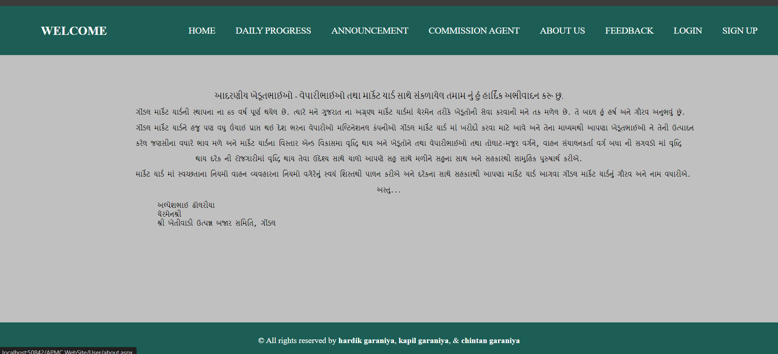

**Coding :-**

**:=>about.aspx**

<%@ Page Language="C#" MasterPageFile="~/User/Index.master" AutoEventWireup="true" CodeFile="about.aspx.cs" Inherits="_Default" Title="Untitled Page" %>

<asp:Content ID="Content1" ContentPlaceHolderID="head" Runat="Server">

<style>

.three{

display: flex;

align-items: center;

justify-content: center;

}

.about

{

width: 1000px;

text-align: center;

}

.two{

text-align: left;

}

</style>

</asp:Content>

<asp:Content ID="Content2" ContentPlaceHolderID="ContentPlaceHolder1" Runat="Server">

<div class="main">

<div class="three">

<div class="about">

<div>

<br />

<br />

<br />

<br />

<br />

<br />

<br />

<br />

<br />

આદરણીય ખેડૂતભાઈઓ - વેપારીભાઈઓ તથા માર્કેટ યાર્ડ સાથે સંકળાયેલ તમામ નું હું હાર્દિક અભીવાદન કરૂ છુ.</div>

<pre>ગોંડલ માર્કેટ યાર્ડની સ્થાપના ના 65 વર્ષ પૂર્ણ થયેલ છે. ત્યારે મને ગુજરાત ના અગ્ર્ણ્ય માર્કેટ યાર્ડમાં ચેરમેન તરીકે ખેડૂતોની સેવા કરવાની મને તક મળેલ છે. તે બદલ હું હર્ષ અને ગૌરવ અનુભવું છું.</pre>

<pre>ગોંડલ માર્કેટ યાર્ડને હજુ પણ વધુ ઉંચાઈ પ્રાપ્ત થઈ દેશ ભરના વેપારીઓ મલ્ટિનેશનલ કંપનીઓ ગોંડલ માર્કેટ યાર્ડ માં ખરીદી કરવા માટે આવે અને તેના માધ્યમથી આપણા ખેડૂતભાઈઓ ને તેની ઉત્પાદન</pre>

<pre>કરેલ જણસીના વધારે ભાવ મળે અને માર્કેટ યાર્ડના વિસ્તાર એન્ડ વિકાસમા વૃદ્ધિ થાય અને ખેડૂતોને તથા વેપારીભાઈઓ તથા તોલાટ-મજુર વર્ગને, વાહન સંચાલનકર્તા વર્ગ બધા ની સગવડો માં વૃદ્ધિ </pre>

<pre>થાય દરેક ની રોજગારીમાં વૃદ્ધિ થાય તેવા ઉદેશ્ય સાથે ચાલો આપણે સહુ સાથે મળીને સહુના સાથ અને સહકારથી સામુહિક પુરુષાર્થ કરીએ.</pre>

<div></div>

<pre>માર્કેટ યાર્ડ માં સ્વચ્છતાના નિયમો વાહન વ્યવહારના નિયમો વગેરેનું સ્વયં શિસ્તથી પાલન કરીએ અને દરેકના સાથે સહકારથી આપણા માર્કેટ યાર્ડ આગવા ગોંડલ માર્કેટ યાર્ડનું ગૌરવ અને નામ વધારીએ.</pre>

<pre>અસ્તુ...</pre>

<pre class="two">

અલ્પેશભાઈ ઢોલરીયા

ચેરમેનશ્રી

શ્રી ખેતીવાડી ઉત્પન્ન બજાર સમિતિ, ગોંડલ

</pre>

</div>

</div>

</div>

</asp:Content>

**:=>about.aspx.cs**

using System;

using System.Collections;

using System.Configuration;

using System.Data;

using System.Linq;

using System.Web;

using System.Web.Security;

using System.Web.UI;

using System.Web.UI.HtmlControls;

using System.Web.UI.WebControls;

using System.Web.UI.WebControls.WebParts;

using System.Xml.Linq;

public partial class _Default : System.Web.UI.Page

{

protected void Page_Load(object sender, EventArgs e)

{

}

}

**Feedback.aspx**

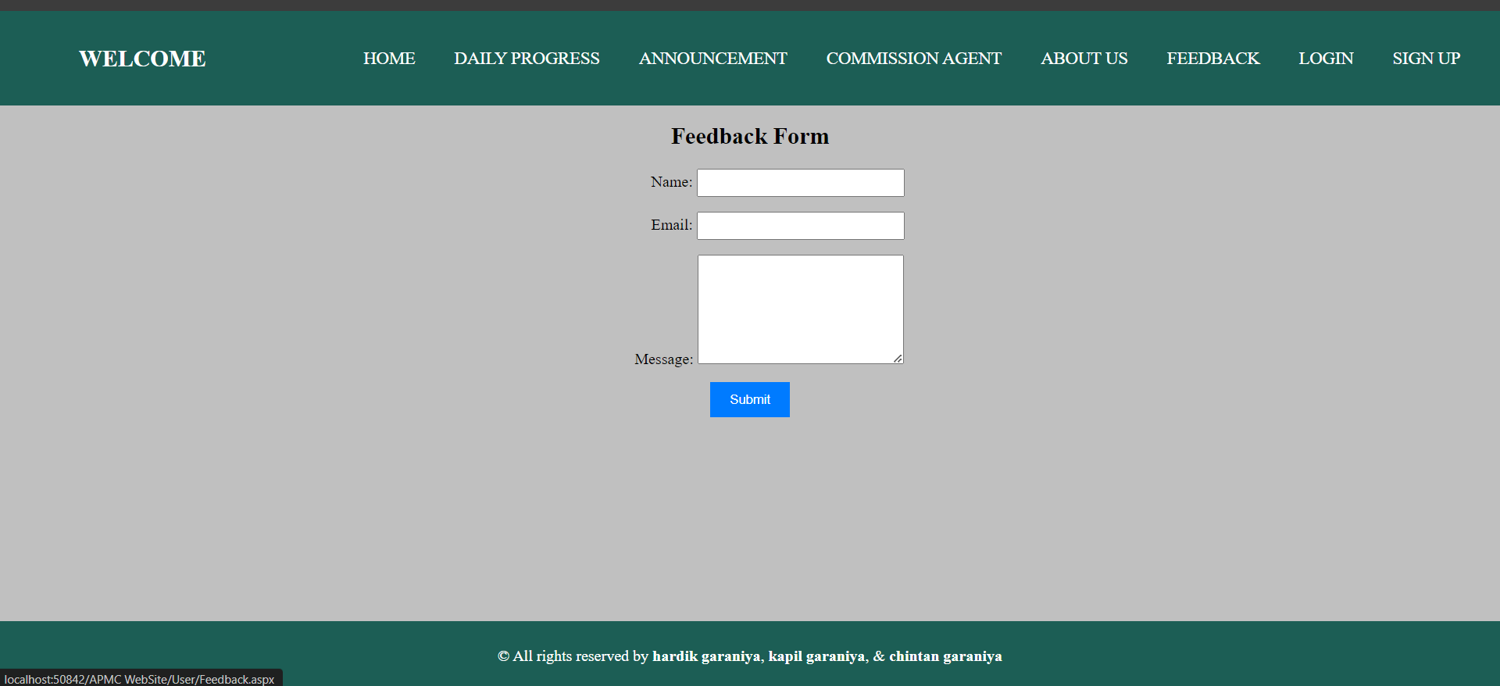

**Coding :-**

**:=>feedback.aspx**

<%@ Page Language="C#" MasterPageFile="~/User/Index.master" AutoEventWireup="true" CodeFile="Feedback.aspx.cs" Inherits="_Default" Title="Untitled Page" %>

<asp:Content ID="Content1" ContentPlaceHolderID="head" Runat="Server">

<style>

.container {

width: 50%;

margin: 0 auto;

text-align: center;

}

.form-group {

margin-bottom: 15px;

}

.form-label {

display: inline-block;

width: 100px;

text-align: right;

}

.form-input {

width: 200px;

padding: 5px;

}

.form-message {

width: 200px;

height: 100px;

padding: 5px;

}

.form-submit {

padding: 10px 20px;

background-color: #007bff;

color: #fff;

border: none;

cursor: pointer;

}

.form-submit:hover {

background-color: #0056b3;

}

</style>

</asp:Content>

<asp:Content ID="Content2" ContentPlaceHolderID="ContentPlaceHolder1" Runat="Server">

<div class="container">

<h2>&nbsp;</h2>

<h2>&nbsp;</h2>

<h2>Feedback Form</h2>

<div class="form-group">

<label class="form-label" for="txtName">Name:</label>

<asp:TextBox ID="txtName" CssClass="form-input" runat="server" MaxLength="20" />

</div>

<div class="form-group">

<label class="form-label" for="txtEmail">Email:</label>

<asp:TextBox ID="txtEmail" CssClass="form-input" runat="server"

MaxLength="40" />

</div>

<div class="form-group">

<label class="form-label" for="txtMessage">Message:</label>

<asp:TextBox ID="txtMessage" CssClass="form-message" TextMode="MultiLine"

Rows="4" runat="server" MaxLength="100" />

</div>

<div class="form-group">

<asp:Button ID="btnSubmit" CssClass="form-submit" Text="Submit" OnClick="btnSubmit_Click" runat="server" />

</div>

</div>

</asp:Content>

**:=>feedback.aspx.cs**

using System;

using System.Collections;

using System.Configuration;

using System.Data;

using System.Linq;

using System.Web;

using System.Web.Security;

using System.Web.UI;

using System.Web.UI.HtmlControls;

using System.Web.UI.WebControls;

using System.Web.UI.WebControls.WebParts;

using System.Xml.Linq;

using System.Data.SqlClient;

public partial class _Default : System.Web.UI.Page

{

protected void Page_Load(object sender, EventArgs e)

{

}

protected void btnSubmit_Click(object sender, EventArgs e)

{

string name = txtName.Text;

string email = txtEmail.Text;

string message = txtMessage.Text;

string connectionString = ConfigurationManager.ConnectionStrings["welcome"].ConnectionString;

using (SqlConnection connection = new SqlConnection(connectionString))

{

connection.Open();

string query = "INSERT INTO Feedback (Name, Email, Message) VALUES (@Name, @Email, @Message)";

using (SqlCommand command = new SqlCommand(query, connection))

{

command.Parameters.AddWithValue("@Name", name);

command.Parameters.AddWithValue("@Email", email);

command.Parameters.AddWithValue("@Message", message);

command.ExecuteNonQuery();

}

}

}

}

**Login.aspx**

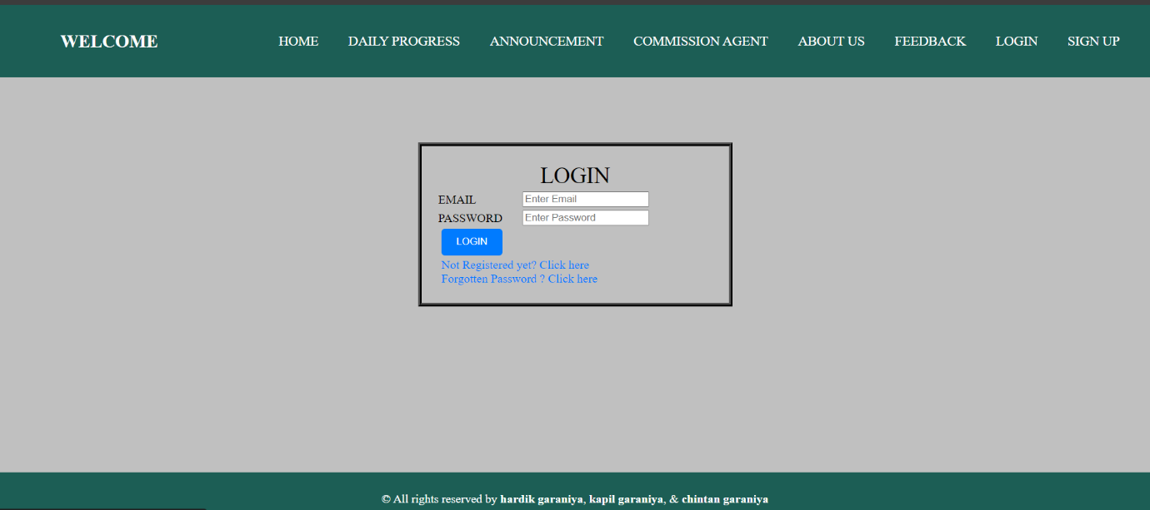

**Coding :-**

**:=>Login.aspx**

<%@ Page Language="C#" MasterPageFile="~/User/Index.master" AutoEventWireup="true" CodeFile="Login.aspx.cs" Inherits="User_Default" Title="Untitled Page" %>

<asp:Content ID="Content1" ContentPlaceHolderID="head" Runat="Server">

<style type="text/css">

.style {

text-align: center;

font-size: 30px;

}

.style1 {

height: 200px;

width: 420px;

margin: auto;

border: 5px black ridge;

padding: 20px;

}

.style3 {

width: 200px;

}

.style4 {

padding: 10px 20px;

background-color: #007bff;

color: #ffffff;

border: none;

cursor: pointer;

border-radius: 5px;

}

.style4:hover {

background-color: #0056b3;

}

.style5 {

text-decoration: none;

color: #007bff;

}

.style5:hover {

text-decoration: underline;

}

.style6

{

width: 76px;

}

</style>

</asp:Content>

<asp:Content ID="Content2" ContentPlaceHolderID="ContentPlaceHolder1" Runat="Server">

<br />

<br />

<br />

<br />

<br />

<br />

<br />

<br />

<br />

<br />

<table class="style1">

<tr>

<td class="style" colspan="2">

LOGIN</td>

</tr>

<tr>

<td class="style6">

EMAIL</td>

<td class="style3">

<asp:TextBox ID="EmailTextBox" runat="server" placeholder="Enter Email" MaxLength="30"></asp:TextBox>

<asp:RequiredFieldValidator ID="RequiredFieldValidator1" runat="server" ControlToValidate="EmailTextBox" Display="Dynamic" ErrorMessage="Please Enter Email" SetFocusOnError="True"></asp:RequiredFieldValidator>

<br />

</td>

</tr>

<tr>

<td class="style6">

PASSWORD</td>

<td class="style3">

<asp:TextBox ID="PassTextBox" runat="server" placeholder="Enter Password" TextMode="Password" MaxLength="10"></asp:TextBox>

<asp:RequiredFieldValidator ID="RequiredFieldValidator2" runat="server" ControlToValidate="PassTextBox" Display="Dynamic" ErrorMessage="Please Enter Password" SetFocusOnError="True"></asp:RequiredFieldValidator>

<br />

</td>

</tr> <tr>

<td colspan="2" class="style3">

&nbsp;<asp:Button ID="LoginButton" runat="server" Text="LOGIN" CssClass="style4" OnClick="LoginButton_Click" />

</td>

</tr>

<tr>

<td colspan="2" class="style3">

&nbsp;<a href="Signup.aspx" class="style5">Not Registered yet? Click here</a>

<br />

&nbsp;<a href="ForgotPass.aspx" class="style5">Forgotten Password ? Click here</a>

</td>

</tr>

</table>

</asp:Content>

**:=>Login.aspx.cs**

using System;

using System.Collections;

using System.Configuration;

using System.Data;

using System.Linq;

using System.Web;

using System.Web.Security;

using System.Web.UI;

using System.Web.UI.HtmlControls;

using System.Web.UI.WebControls;

using System.Web.UI.WebControls.WebParts;

using System.Xml.Linq;

using System.Data.SqlClient;

using System.Security.Cryptography;

using System.Text;

public partial class User_Default : System.Web.UI.Page

{

string cs = ConfigurationManager.ConnectionStrings["welcome"].ConnectionString;

protected void Page_Load(object sender, EventArgs e)

{

}

protected void LoginButton_Click(object sender, EventArgs e)

{

string email = EmailTextBox.Text;

string password = PassTextBox.Text;

string connectionString = ConfigurationManager.ConnectionStrings["welcome"].ConnectionString;

using (SqlConnection connection = new SqlConnection(connectionString))

{

connection.Open();

using (SqlCommand checkUser = new SqlCommand("SELECT UserId, Firmname, UserType, IsApproved FROM [User] WHERE Email = @Email AND Password = @Password", connection))

{

checkUser.Parameters.AddWithValue("@Email", email);

checkUser.Parameters.AddWithValue("@Password", password);

using (SqlDataReader reader = checkUser.ExecuteReader())

{

if (reader.Read())

{

string approvalStatus = reader["IsApproved"].ToString();

if (approvalStatus == "True")

{

Session["Email"] = email;

Session["UserId"] = Convert.ToInt32(reader["UserId"]);

Session["Firmname"] = reader["Firmname"].ToString();

if (reader["UserType"].ToString() == "Admin")

{

Response.Redirect("~/Admin/Home.aspx");

}

else

{

Response.Redirect("~/C.A/Home.aspx");

}

}

else

{

Page.ClientScript.RegisterStartupScript(this.GetType(), "Script", "<script>alert('Your account is not approved. Please wait for approval.');</script>");

}

}

else

{

Page.ClientScript.RegisterStartupScript(this.GetType(), "Script", "<script>alert('Invalid email or password');</script>");

}

}

}

}

}

}

**Signup.aspx**

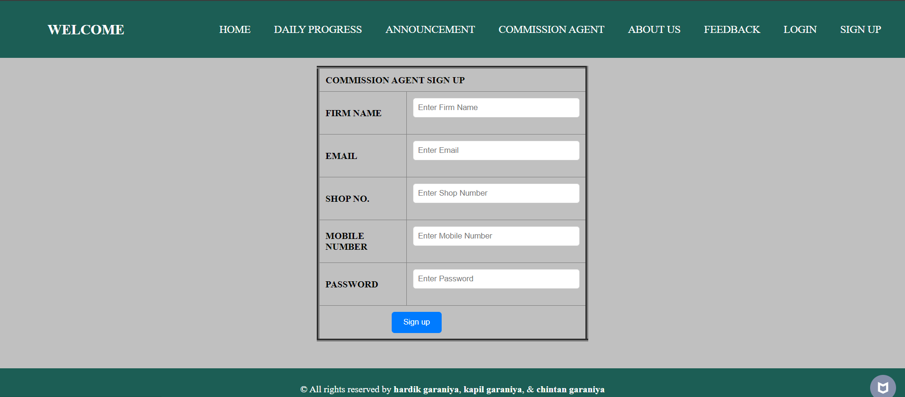

**Coding :-**

**:=>Signup.aspx**

<%@ Page Language="C#" MasterPageFile="~/User/Index.master" AutoEventWireup="true" CodeFile="Signup.aspx.cs" Inherits="User_Default" Title="Untitled Page" %>

<asp:Content ID="Content1" ContentPlaceHolderID="head" Runat="Server">

<style type="text/css">

.signup-table {

margin: 0 auto;

width: 30%;

border-collapse: collapse;

}

.signup-table td {

padding: 10px;

}

.signup-label {

font-weight: bold;

}

.signup-input {

width: 100%;

padding: 8px;

border: 1px solid #ccc;

border-radius: 5px;

box-sizing: border-box;

}

.signup-button {

padding: 10px 20px;

background-color: #007bff;

color: #ffffff;

border: none;

cursor: pointer;

border-radius: 5px;

}

.signup-button:hover {

background-color: #0056b3;

}

</style>

</asp:Content>

<asp:Content ID="Content2" ContentPlaceHolderID="ContentPlaceHolder1" Runat="Server">

<br />

<br />

<br />

<br />

<br />

<br />

<table class="signup-table" border="5px">

<tr>

<td colspan="2" class="signup-label">COMMISSION AGENT SIGN UP</td>

</tr>

<tr>

<td class="signup-label">FIRM NAME</td>

<td>

<asp:TextBox ID="FirmTextBox" runat="server" CssClass="signup-input"

MaxLength="40" placeholder="Enter Firm Name"></asp:TextBox>

<asp:RequiredFieldValidator ID="RequiredFieldValidator1" runat="server" ControlToValidate="FirmTextBox" ErrorMessage="Please enter name"></asp:RequiredFieldValidator>

</td>

</tr>

<tr>

<td class="signup-label">EMAIL</td>

<td>

<asp:TextBox ID="EmailTextBox" runat="server" CssClass="signup-input"

MaxLength="30" placeholder="Enter Email"></asp:TextBox>

<asp:RequiredFieldValidator ID="RequiredFieldValidator2" runat="server" ControlToValidate="EmailTextBox" ErrorMessage="Please enter email"></asp:RequiredFieldValidator>

</td>

</tr>

<tr>

<td class="signup-label">SHOP NO.</td>

<td>

<asp:TextBox ID="ShopTextBox" runat="server" CssClass="signup-input"

MaxLength="8" placeholder="Enter Shop Number"></asp:TextBox>

<asp:RequiredFieldValidator ID="RequiredFieldValidator3" runat="server" ControlToValidate="ShopTextBox" ErrorMessage="Please enter shop number"></asp:RequiredFieldValidator>

</td>

</tr>

<tr>

<td class="signup-label">MOBILE NUMBER</td>

<td>

<asp:TextBox ID="MoTextBox" runat="server" CssClass="signup-input"

MaxLength="12" placeholder="Enter Mobile Number"></asp:TextBox>

<asp:RequiredFieldValidator ID="RequiredFieldValidator5" runat="server" ControlToValidate="MoTextBox" ErrorMessage="Please enter mobile number"></asp:RequiredFieldValidator>

</td>

</tr>

<tr>

<td class="signup-label">PASSWORD</td>

<td>

<asp:TextBox ID="PassTextBox" runat="server" TextMode="Password"

CssClass="signup-input" MaxLength="8" placeholder="Enter Password"></asp:TextBox>

<asp:RequiredFieldValidator ID="RequiredFieldValidator4" runat="server" ControlToValidate="PassTextBox" ErrorMessage="Please enter password"></asp:RequiredFieldValidator>

</td>

</tr>

<tr>

<td colspan="2">

&nbsp;&nbsp;&nbsp;&nbsp;&nbsp;&nbsp;&nbsp;&nbsp;&nbsp;&nbsp;&nbsp;&nbsp;&nbsp;&nbsp;&nbsp;&nbsp;&nbsp;&nbsp;&nbsp;&nbsp;&nbsp;&nbsp;&nbsp;&nbsp;&nbsp;&nbsp;

<asp:Button ID="Button1" runat="server" Text="Sign up" CssClass="signup-button" OnClick="Button1_Click" />

&nbsp;

</td>

</tr>

</table>

</asp:Content>

**:=>Signup.aspx.cs**

using System;

using System.Collections;

using System.Configuration;

using System.Data;

using System.Linq;

using System.Web;

using System.Web.Security;

using System.Web.UI;

using System.Web.UI.HtmlControls;

using System.Web.UI.WebControls;

using System.Web.UI.WebControls.WebParts;

using System.Xml.Linq;

using System.Data.SqlClient;

public partial class User_Default : System.Web.UI.Page

{

string cs = ConfigurationManager.ConnectionStrings["welcome"].ConnectionString;

protected void Page_Load(object sender, EventArgs e)

{

}

protected void Button1_Click(object sender, EventArgs e)

{

SqlConnection con = new SqlConnection(cs);

string query = "INSERT INTO [User] (Firmname, Password, Shopnumber, Email, Mobilenumber, UserType) VALUES (@Firmname, @Password, @Shopnumber, @Email, @Mobilenumber, 'User')";

SqlCommand cmd = new SqlCommand(query, con);

cmd.Parameters.AddWithValue("@Firmname", FirmTextBox.Text);

cmd.Parameters.AddWithValue("@Password", PassTextBox.Text);

cmd.Parameters.AddWithValue("@Shopnumber", ShopTextBox.Text);

cmd.Parameters.AddWithValue("@Email", EmailTextBox.Text);

cmd.Parameters.AddWithValue("@Mobilenumber", MoTextBox.Text);

con.Open();

int a = cmd.ExecuteNonQuery();

if (a > 0)

{

Response.Write("<script>alert('Inserted Successfully !!')</script>");

}

else

{

Response.Write("<script>alert('Inserted failed !!')</script>");

}

con.Close();

}

}

**ForgotPass.aspx**

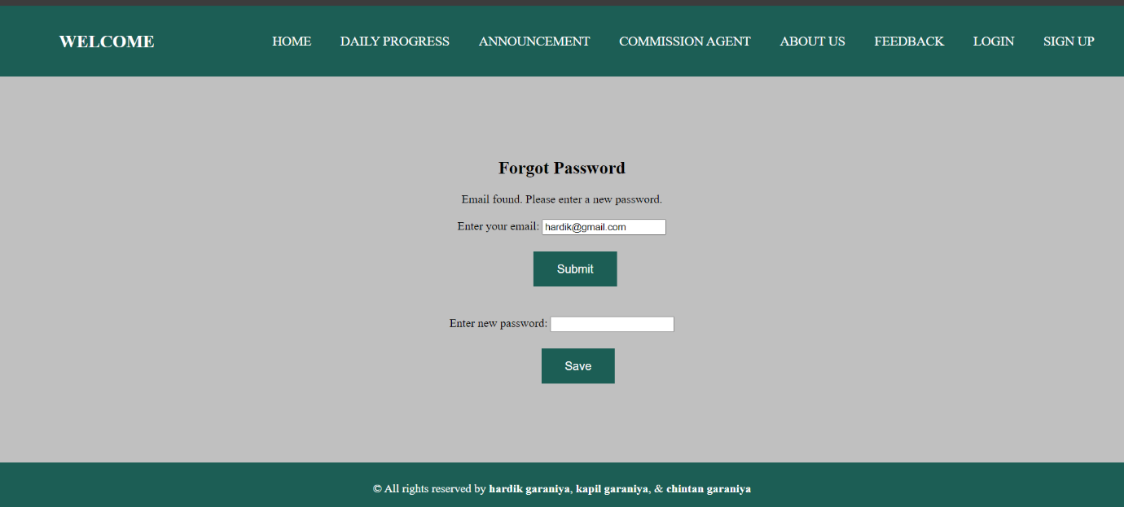

**Coding :-**

**:=>ForgotPass.aspx**

<%@ Page Language="C#" MasterPageFile="~/User/Index.master" AutoEventWireup="true" CodeFile="ForgotPass.aspx.cs" Inherits="User_ForgotPass" Title="Forgot Password" %>

<asp:Content ID="Content1" ContentPlaceHolderID="head" Runat="Server">

<style>

input[type="button"],

input[type="submit"],

button {

background-color: #1C5E55;

border: none;

color: white;

padding: 15px 32px;

text-align: center;

text-decoration: none;

display: inline-block;

font-size: 16px;

margin: 4px 2px;

cursor: pointer;

}

input[type="button"]:hover,

input[type="submit"]:hover,

button:hover {

background-color:#1C5E55;

}

.c {

text-align: center;

}

</style>

</asp:Content>

<asp:Content ID="Content2" ContentPlaceHolderID="ContentPlaceHolder1" Runat="Server">

<div class="c">

<h2>&nbsp;</h2>

<h2>&nbsp;</h2>

<h2>&nbsp;</h2>

<h2>&nbsp;</h2>

<h2>Forgot Password</h2>

<asp:Label ID="StatusLabel" runat="server" Text=""></asp:Label>

<br />

<br />

Enter your email: <asp:TextBox ID="EmailTextBox" runat="server"></asp:TextBox>

<br />

<br />

&nbsp;&nbsp;&nbsp;&nbsp;&nbsp;&nbsp;&nbsp;&nbsp;

<asp:Button ID="SubmitButton" runat="server" Text="Submit" OnClick="SubmitButton_Click" />

<asp:Panel ID="NewPasswordPanel" runat="server" Visible="false">

<br />

<br />

Enter new password: <asp:TextBox ID="NewPasswordTextBox" runat="server" TextMode="Password"></asp:TextBox>

<br />

<br />

&nbsp;&nbsp;&nbsp;&nbsp;&nbsp;&nbsp;&nbsp;&nbsp;&nbsp;&nbsp;

<asp:Button ID="SavePasswordButton" runat="server" Text="Save" OnClick="SavePasswordButton_Click" />

</asp:Panel>

</div>

</asp:Content>

**:=>ForgotPass.aspx.cs**

using System;

using System.Collections;

using System.Configuration;

using System.Data;

using System.Linq;

using System.Web;

using System.Web.Security;

using System.Web.UI;

using System.Web.UI.HtmlControls;

using System.Web.UI.WebControls;

using System.Web.UI.WebControls.WebParts;

using System.Xml.Linq;

using System.Data.SqlClient;

public partial class User_ForgotPass : System.Web.UI.Page

{

string cs = ConfigurationManager.ConnectionStrings["welcome"].ConnectionString;

protected void Page_Load(object sender, EventArgs e)

{

}

protected void SubmitButton_Click(object sender, EventArgs e)

{

string email = EmailTextBox.Text;

if (IsEmailExists(email))

{

StatusLabel.Text = "Email found. Please enter a new password.";

NewPasswordPanel.Visible = true;

}

else

{

StatusLabel.Text = "Email not found. Please enter a valid email address.";

}

}

protected void SavePasswordButton_Click(object sender, EventArgs e)

{

string email = EmailTextBox.Text;

string newPassword = NewPasswordTextBox.Text;

UpdatePassword(email, newPassword);

StatusLabel.Text = "Password updated successfully.";

Response.Redirect("Login.aspx");

}

private bool IsEmailExists(string email)

{

using (SqlConnection con = new SqlConnection(cs))

{

SqlCommand cmd = new SqlCommand("SELECT COUNT(*) FROM [User] WHERE Email = @Email", con);

cmd.Parameters.AddWithValue("@Email", email);

con.Open();

int count = (int)cmd.ExecuteScalar();

return count > 0;

}

}

private void UpdatePassword(string email, string newPassword)

{

using (SqlConnection con = new SqlConnection(cs))

{

SqlCommand cmd = new SqlCommand("UPDATE [User] SET Password = @Password WHERE Email = @Email", con);

cmd.Parameters.AddWithValue("@Password", newPassword);

cmd.Parameters.AddWithValue("@Email", email);

con.Open();

cmd.ExecuteNonQuery();

}

}

}

**Testing**

**Importance of software Testing**

He importance of software testing and its impact on software cannot be underestimated. Software testing is a fundamental component of software quality assurance and represents a review of specification, design and coding. The greater visibility of software system and the code associated with software failure are motivating factors for planning, through testing. It is not uncommon for a software organization to spent 40% of its efforts on testing.

**Software Testing Fundamentals**

During testing the software engineering produces a series of test cases that are used to “rip apart” the software they have produced. Testing is the one step in the software process that can be seen by the developer as destructive instead of constructive. Software engineers are typically constructive people and testing requires them to overcome preconceived concepts of correctness and deal with conflicts when errors are identified.

**Black Box Testing**

Black box testing relates to the tests that are performed at the software interface. Although they are designed identify errors, black box tests are used to demonstrate that software function are operational; that inputs are correctly accepted and the output is correctly produced. A black box test considers elements of the system with little interest in the internal logical arrangement of the software. White box testing of the testing involve closer examination of procedural detail. Logical paths through the software are considered by providing test cases that exercise particular sets of conditions and / or loops. The status of the system can be identified at diverse points to establish if the expected status matches the actual status.

Black box testing tries to find errors in the following categories:

1. Incorrect or missing functions,

2. Interface errors,

3. Errors in data structures or external database access,

4. Performance errors, and

5. Initialization and termination errors.

**White Box Testing**

White box testing is a test case design approach that employees the control architecture of the procedural design to produce test cases. Using white box test approaches, the software engineering can produce test cases

1. Guarantee that all independent paths in a module have been exercised at least once.
2. Exercise all logical decisions.
3. Execute all loops at their boundaries and in their operational bounds. Exercise internal data structures to maintain their validity.

**Future Scope**

* We will keep the logo photo on the home page in the header.
* In the home page ,we will show the total of all crops in yard in website.

.

**Limitation**

* This System is temporary not provide message, video gallery.
* This system is temporary use from company employees.

**Bibliography**

* **Books**

1. System Analysis and Design.

By: James A Sen.

2. Software Engineering.

By: Roger Pressman.

3. Professional ASP.NET 2.0

* **Web site**

[www.google.com](http://www.google.com)

[www.wikipedia.com](http://www.wikipedia.com)

**Special Thanks**

🡪 Prof J. M. Ardeshna

🡪 Prof. V. M. Isotiya

At last but not least, we would like to extend our thanks to all supports, including family members and as well as our classmates and external friends who have helped us implicitly or explicitly. No amount of words written here will suffice for our sense of gratitude towards all of them.